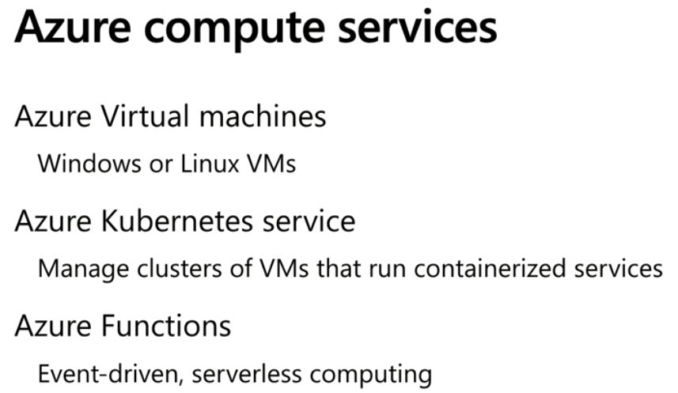  
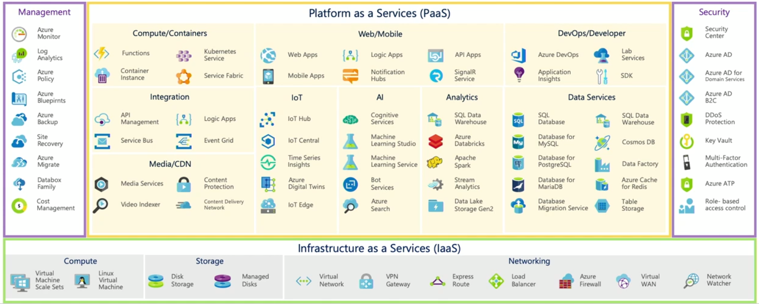  
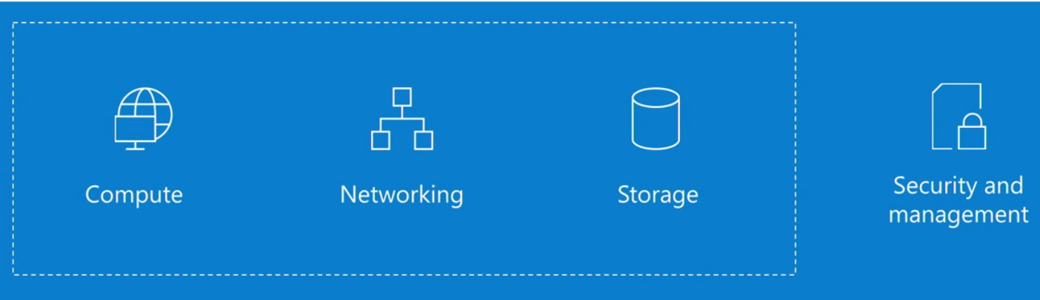  
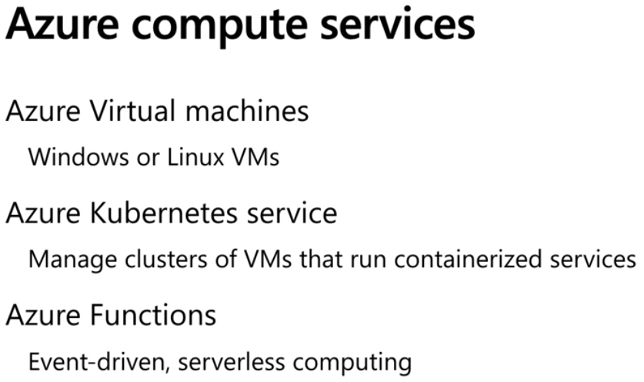 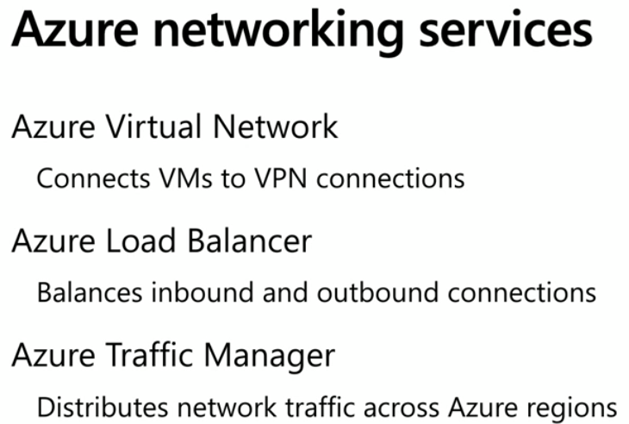  
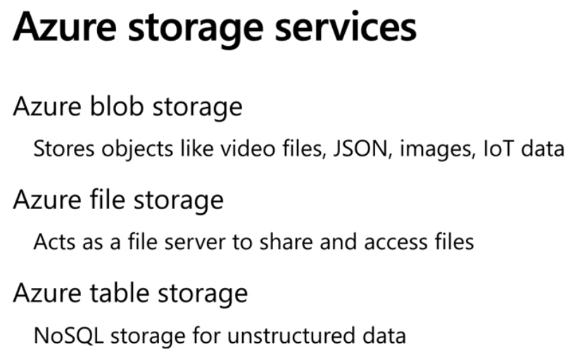  
Azure resource manager (ARM)

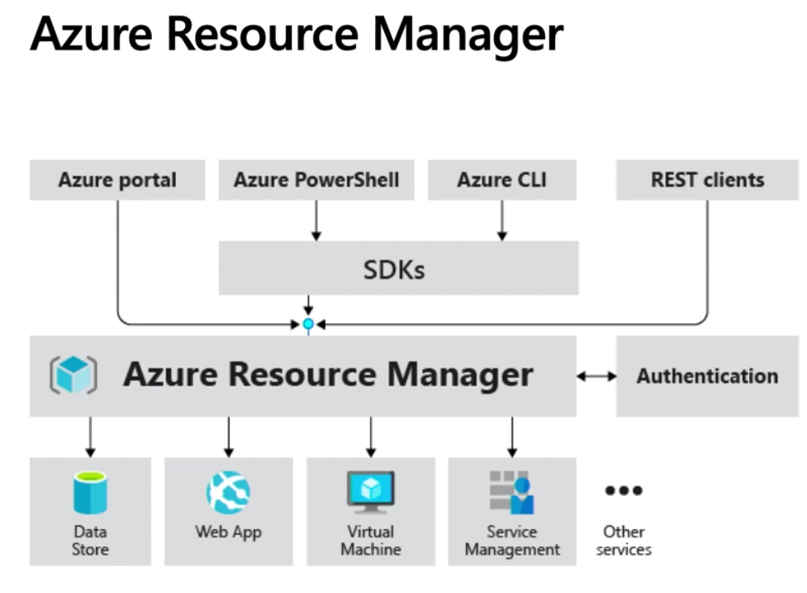  
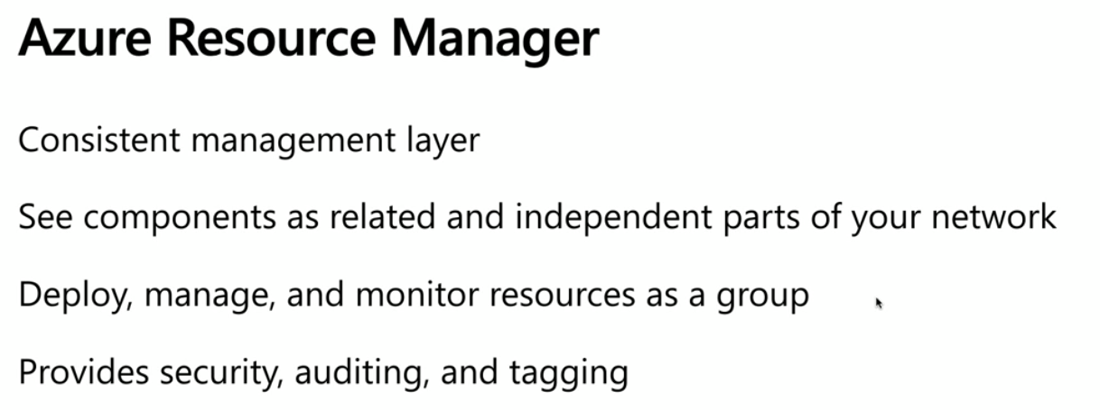  
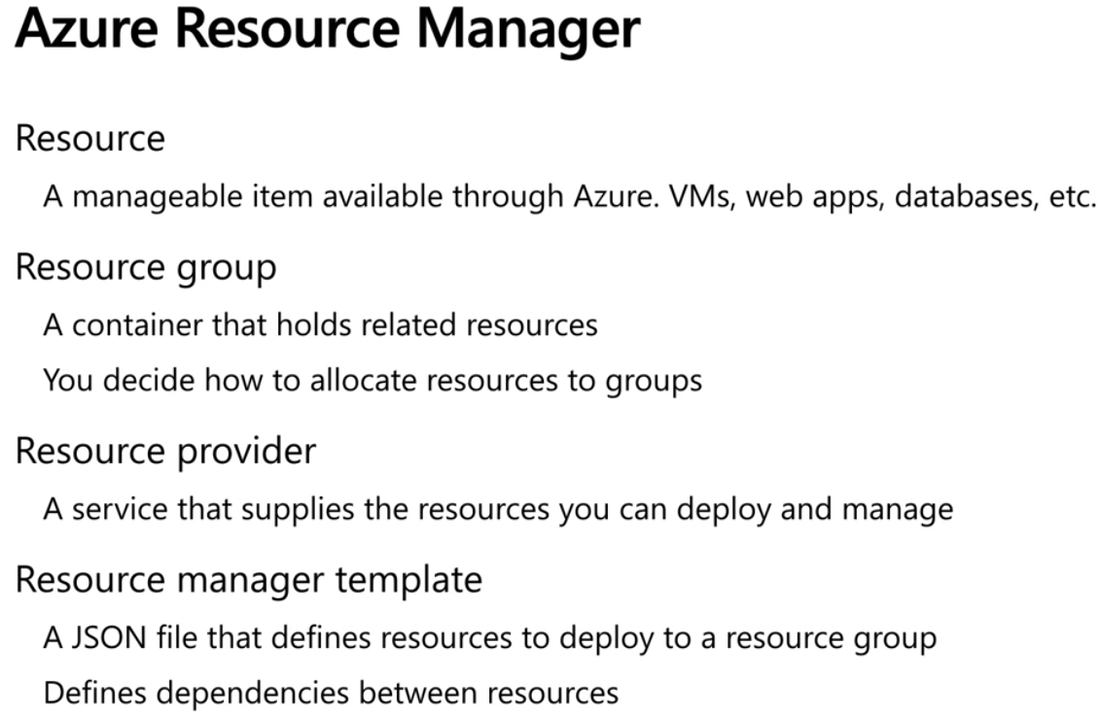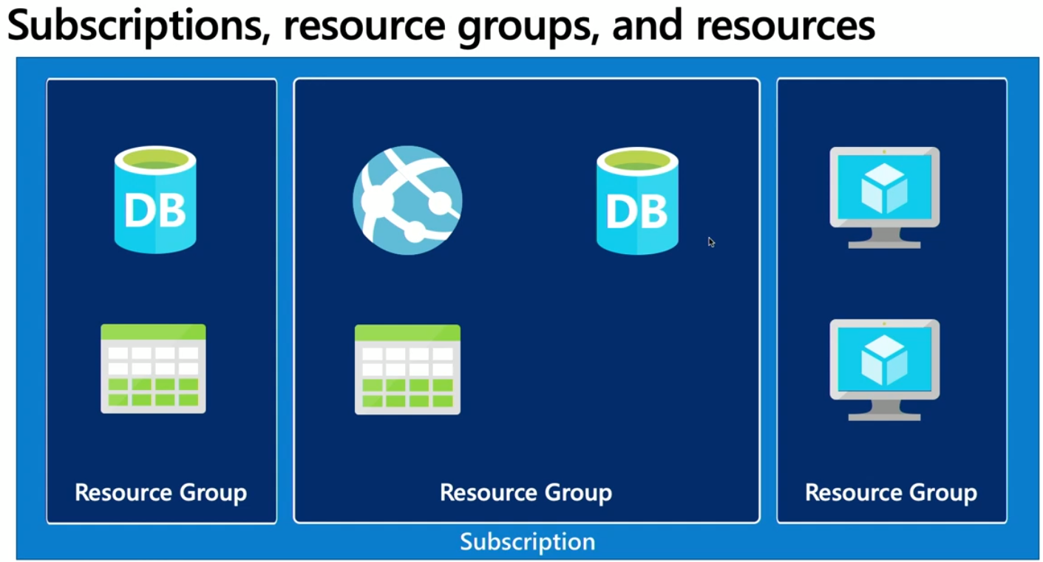  
Resource providers are services that creates resources for us  
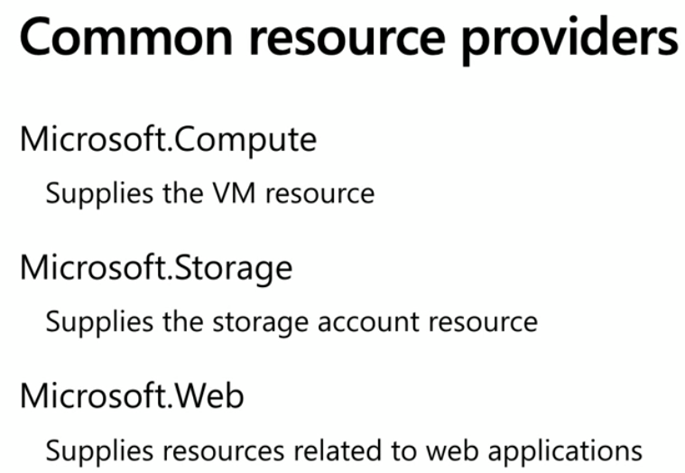  
  
  
  
Resource manager template JSON example that details out all resources and interdependencies. Easy to recreate when required later. PoweShell/CLI/AzurePortal can consume this JSON to create resources.  
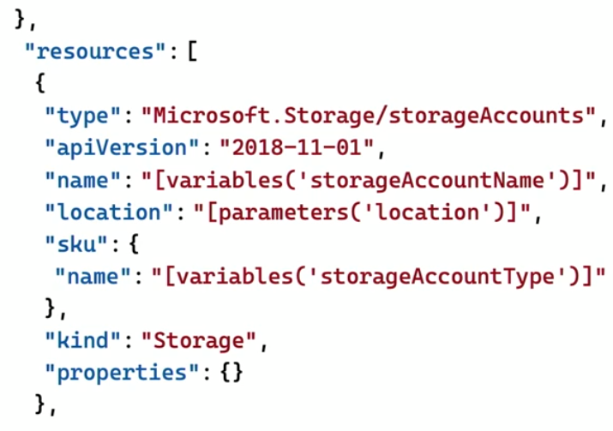  
Compute Options is about possible Hardware Processor, Memory configurations  
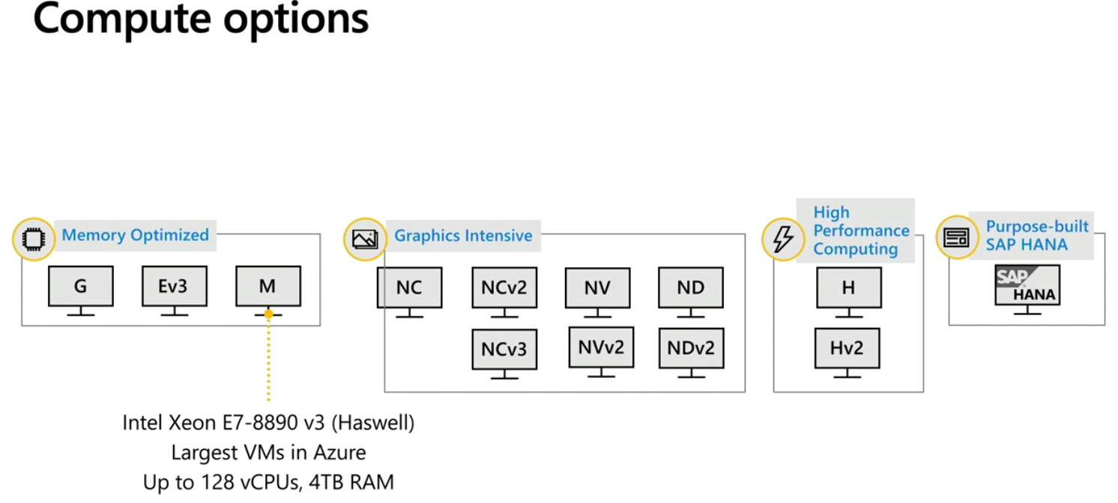  
Virtual Machines, Containers are part of IaaS and come under compute section  
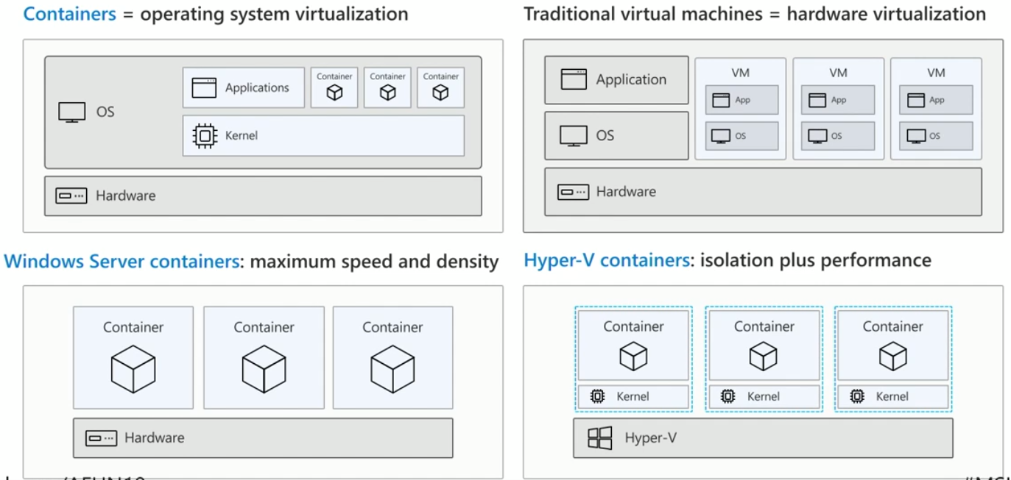  
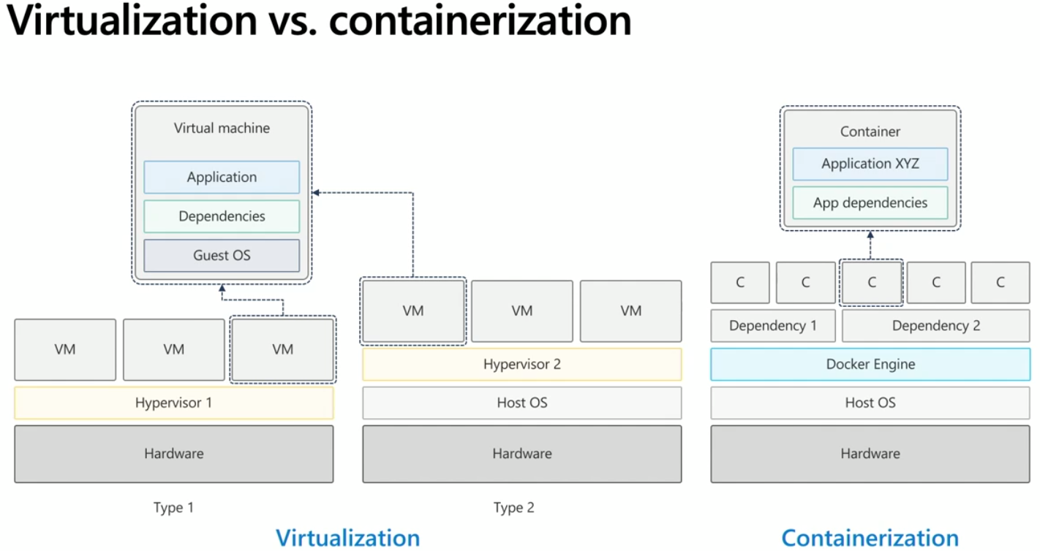  
VM being created from Azure Portal  
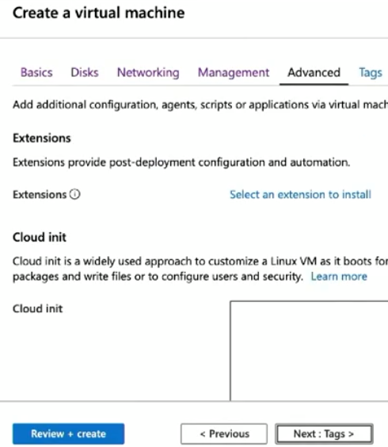  
Downloading an ARM template for usage later  
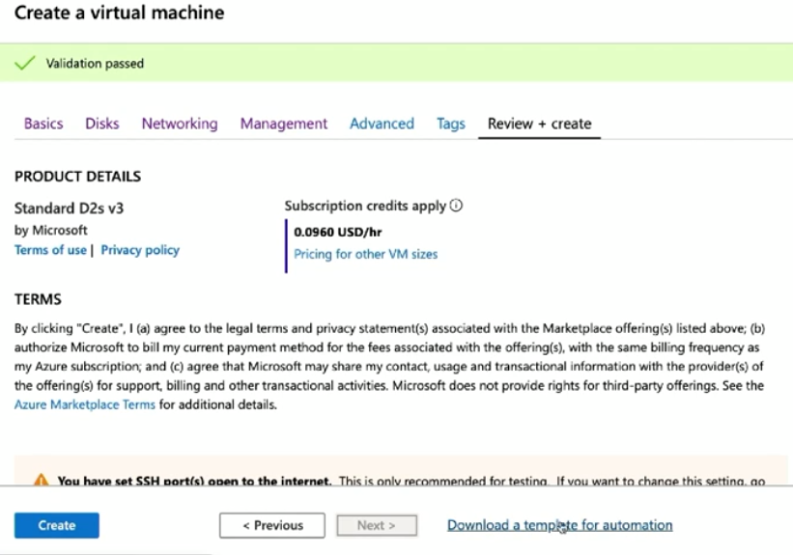  
  
VM being created from CLI  
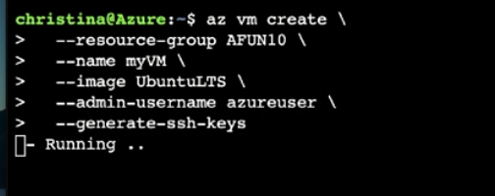  
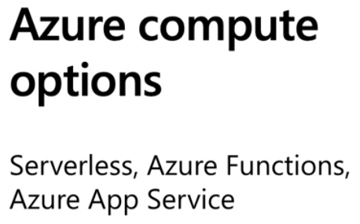  
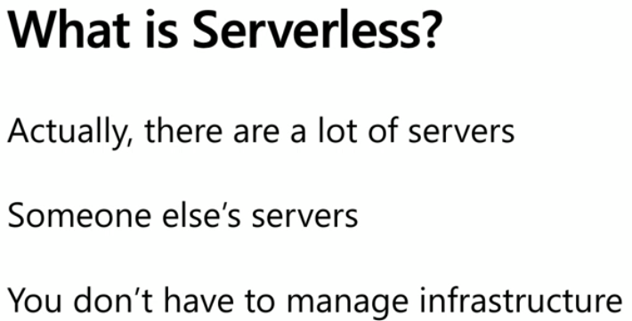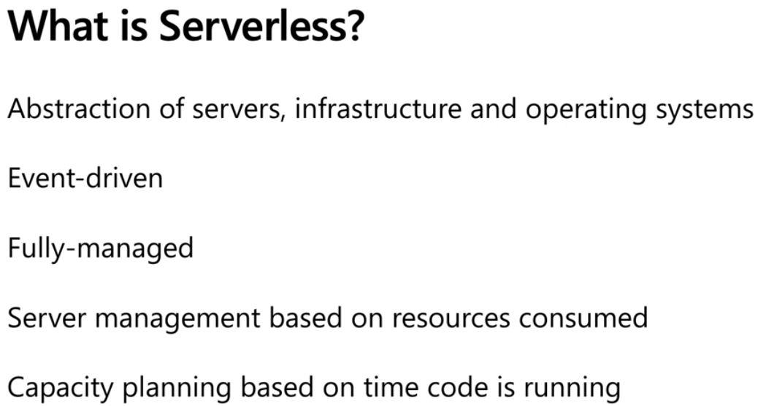  
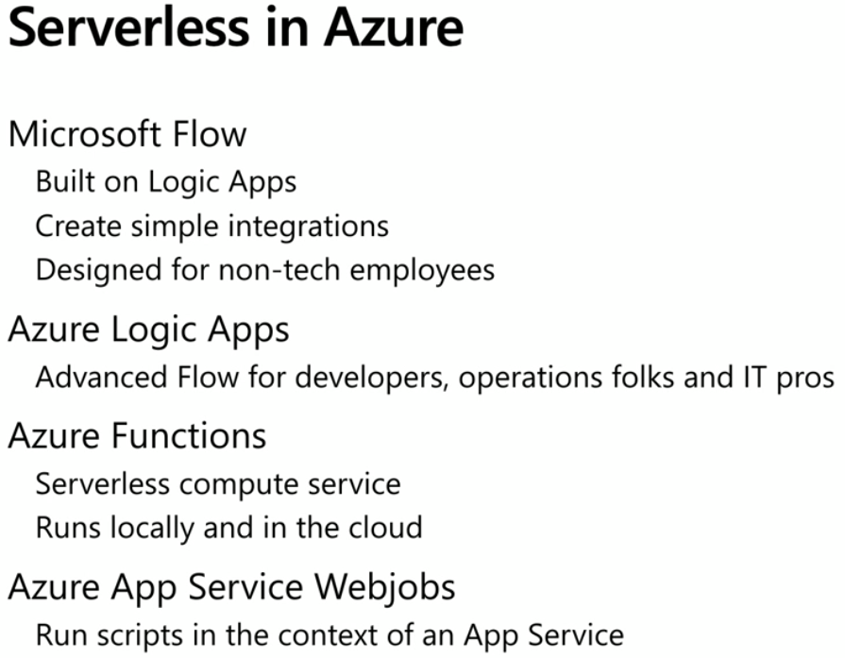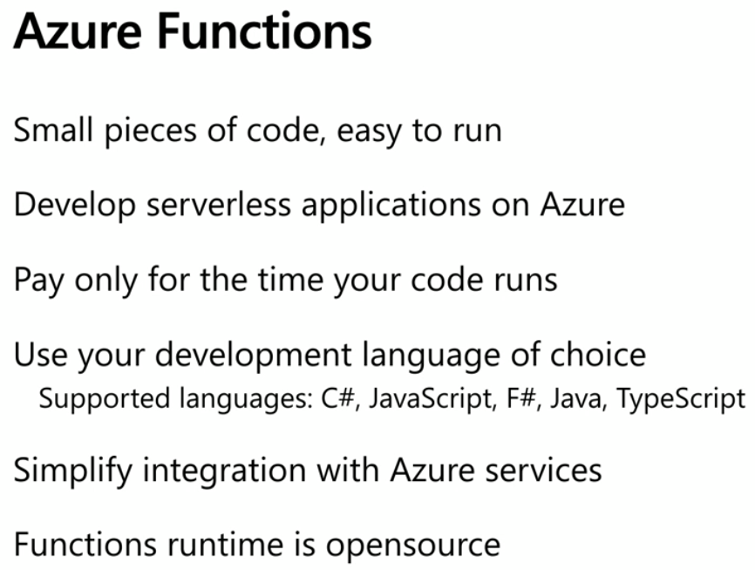  
  
  
You can have auto deply from github  
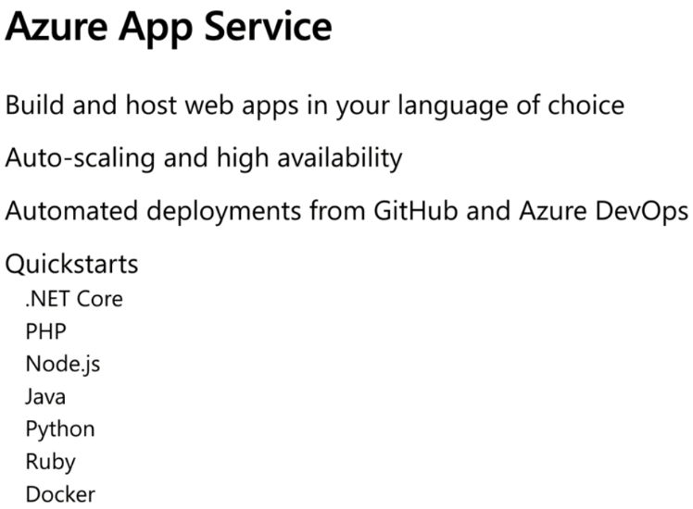I have created code for this app.  
I do not know what I need to do underneath it.  
But I can create an App Service.  
App service will create a container instance.  
App service will say, ok, I see you are using javascript in this app. It will create a container with javascript related dependencies.

Compute Service Decision Tree  
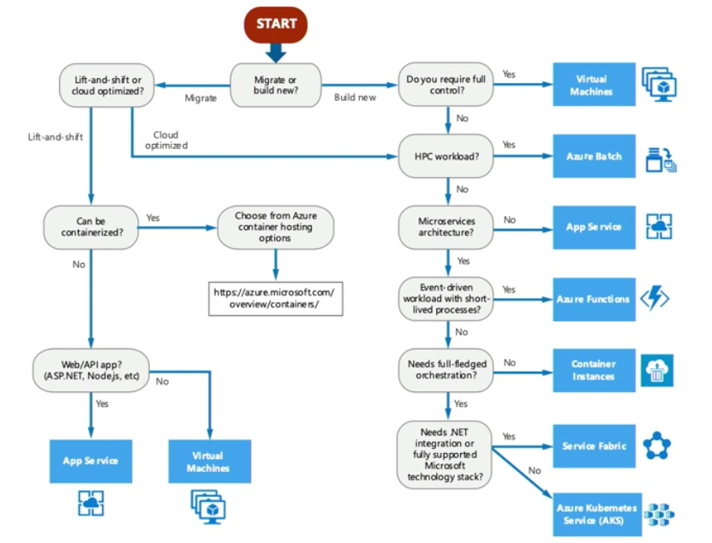  
Azure Network  
  
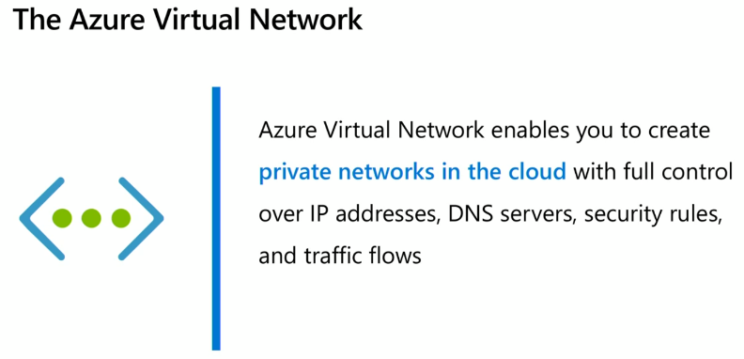Multiple Virtual networks can be created within subscription. Two Virtual networks can be connected. This is VNet Peering if connecting Vnets within the same Azure region. If across regions, we call it Global VNet peering. After Vnet peering, resources in either virtual network can directly connect with resource in the peered network. On prem can be connected to Virtual Network.  
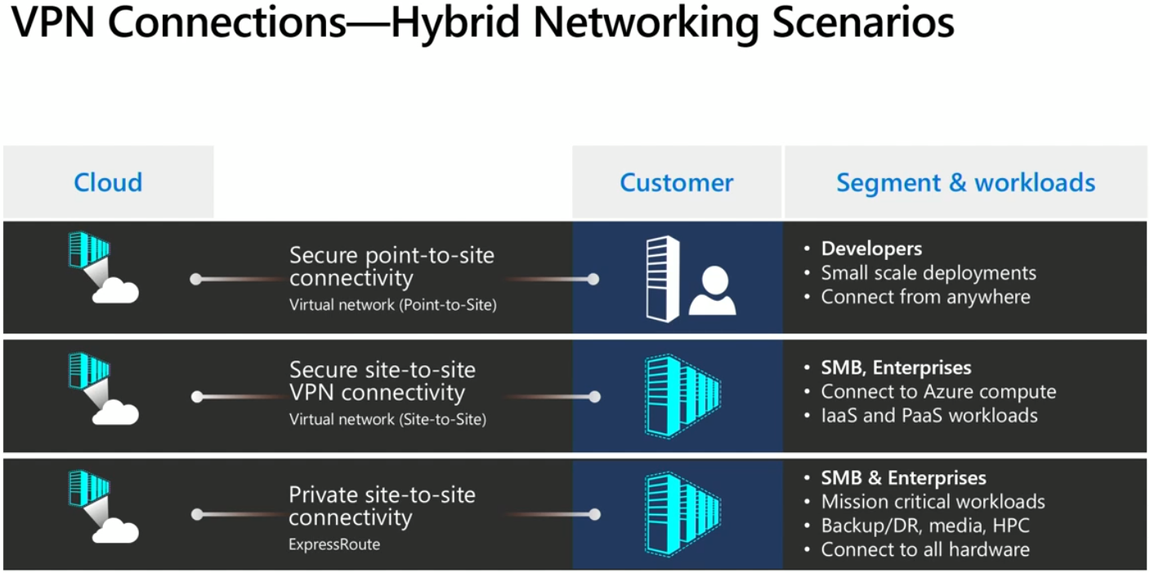

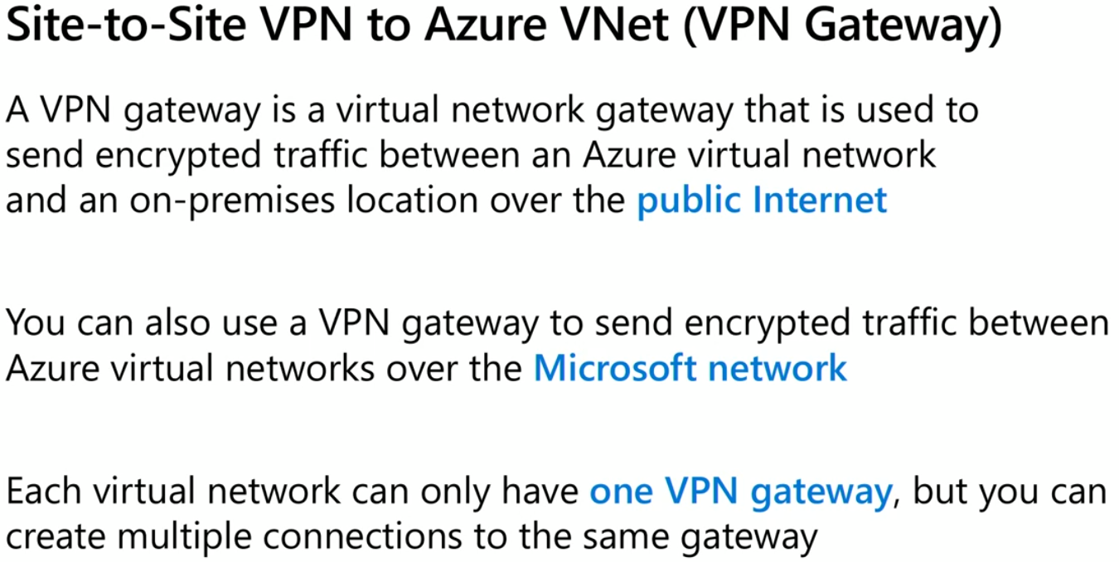  
Site to Site VPN Gateway can be used to communicate between On-Prem and Azure Virtual Network but this happens over public internet. If we are worried about data privacy, we can opt for Express Route that does not go over public internet and is faster than public internet. Direct private connection.  
  
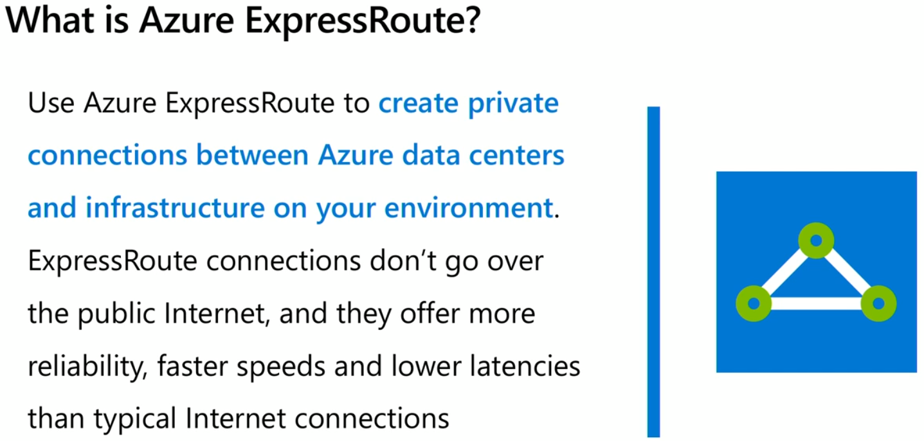  
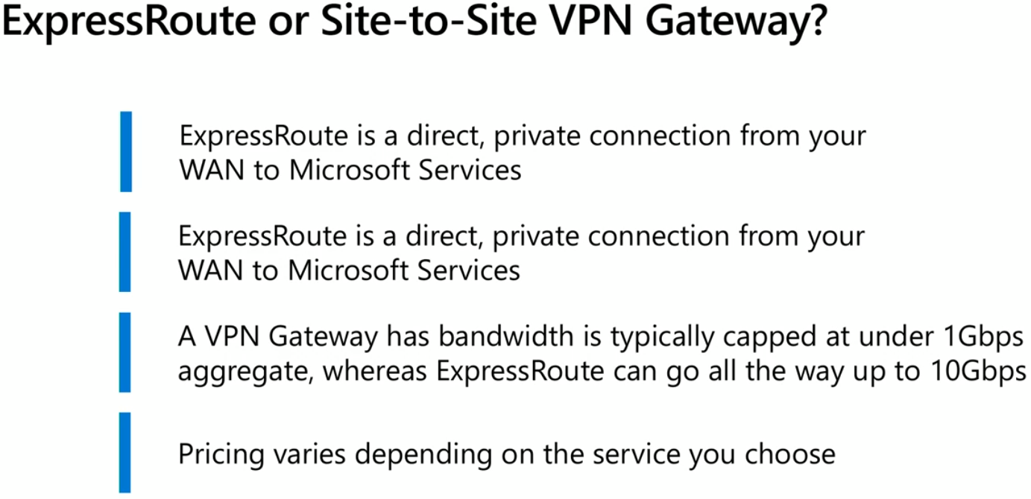

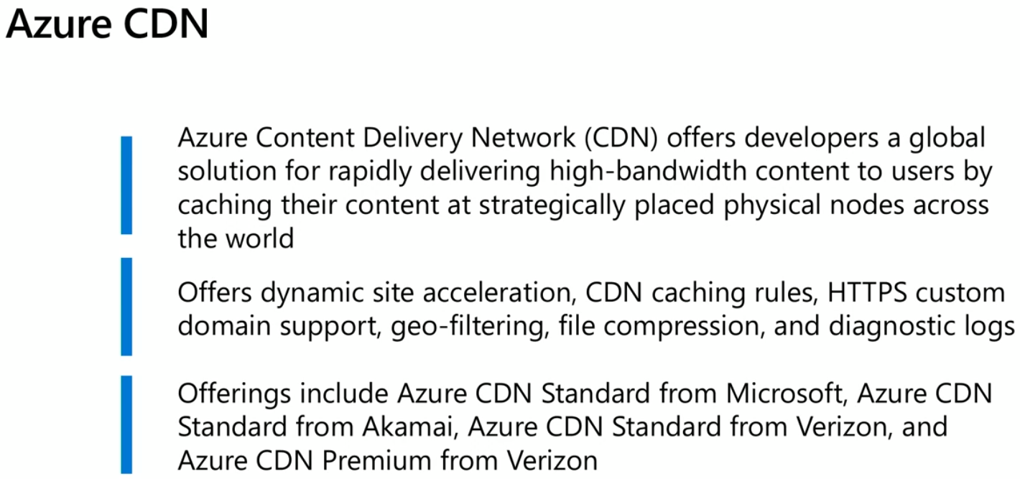  
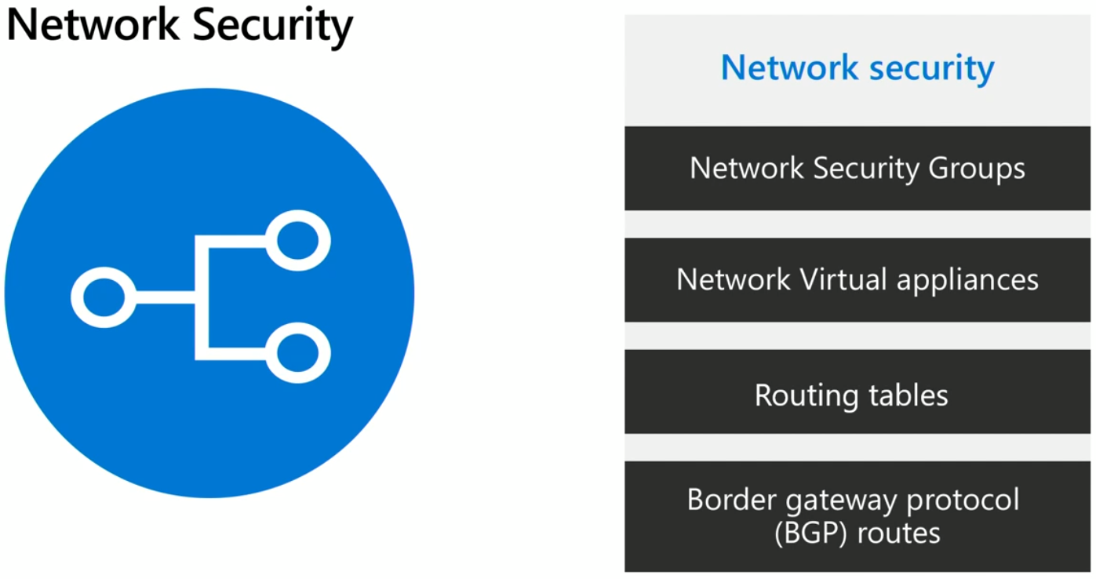  
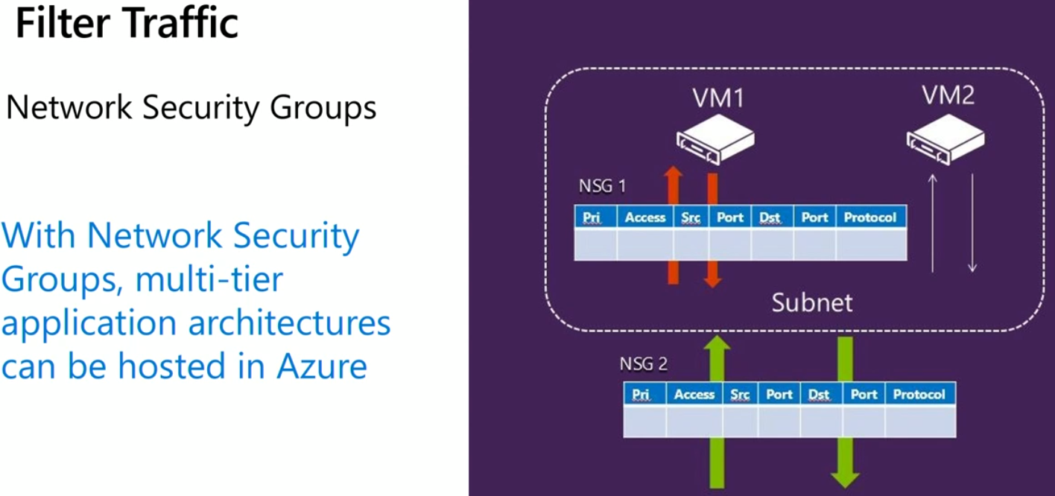  
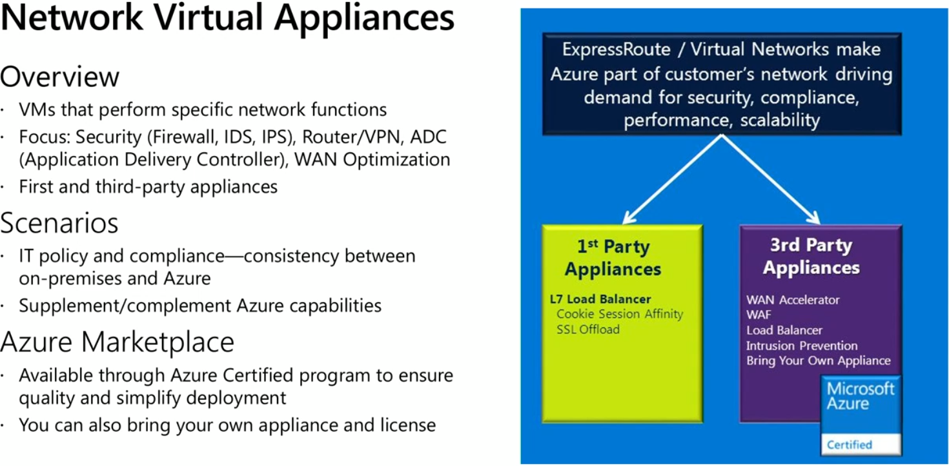  
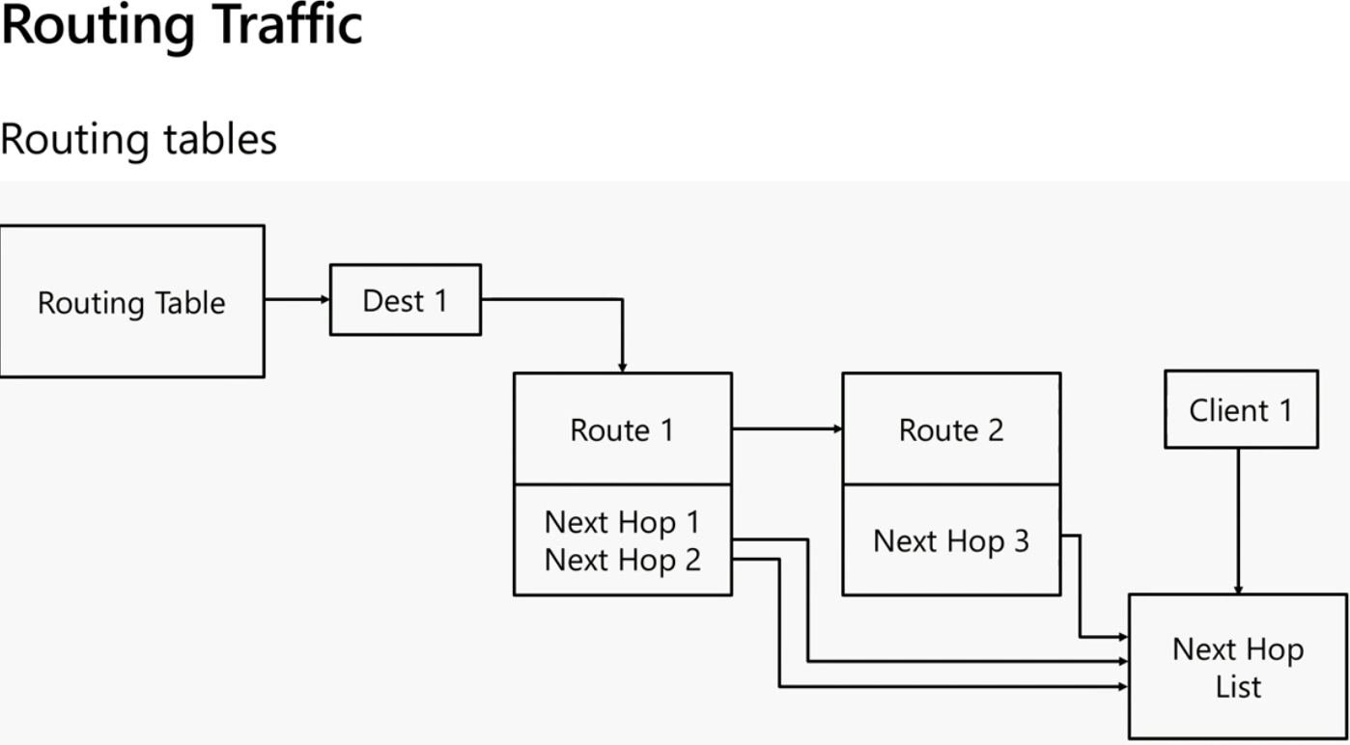  
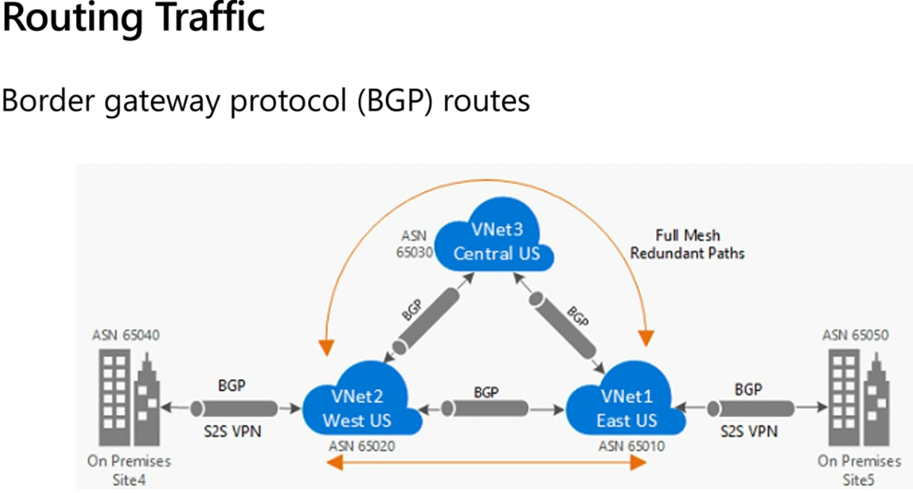  
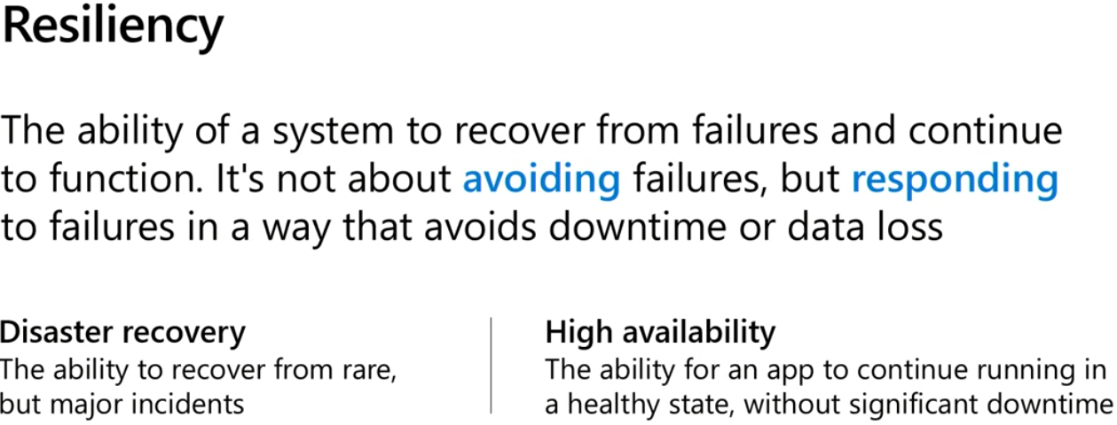  
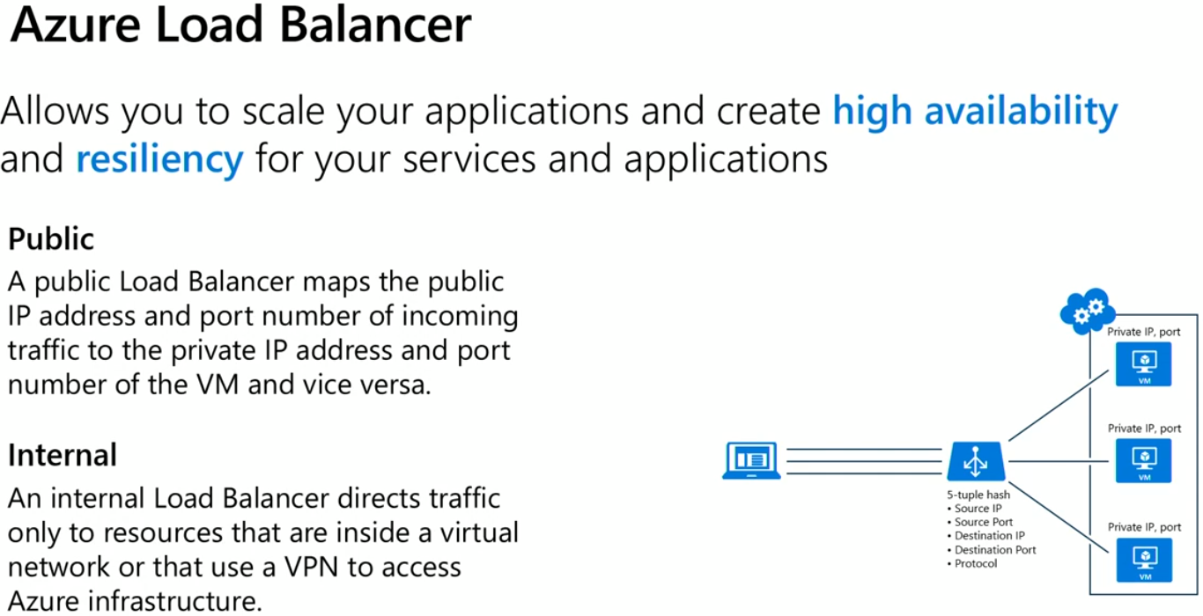

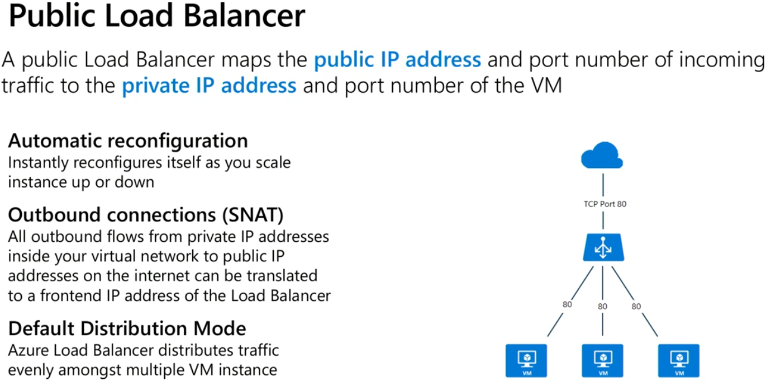  
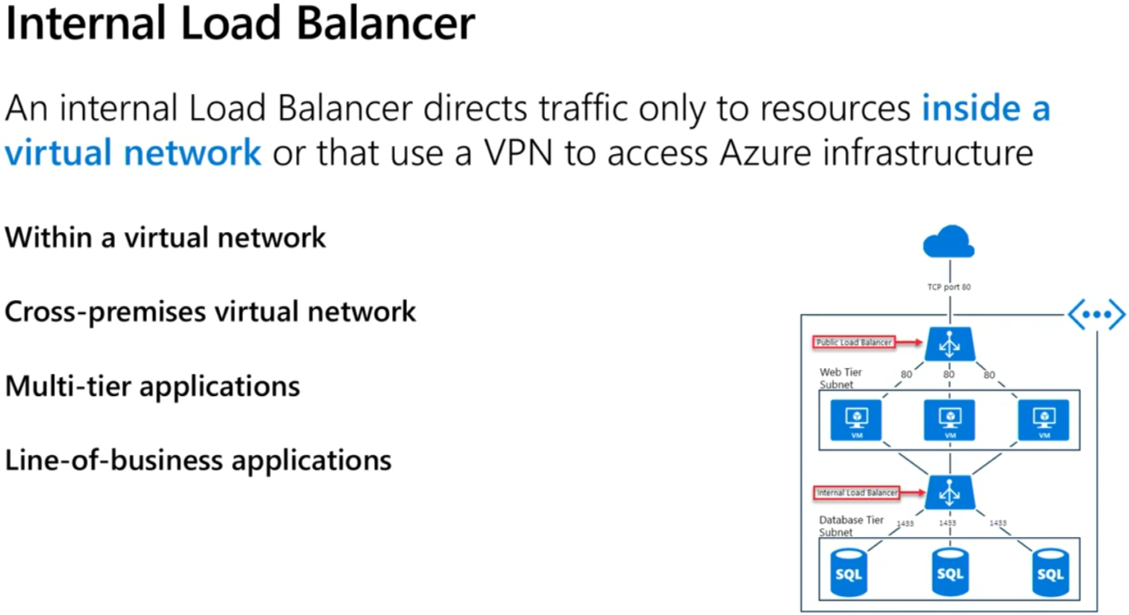

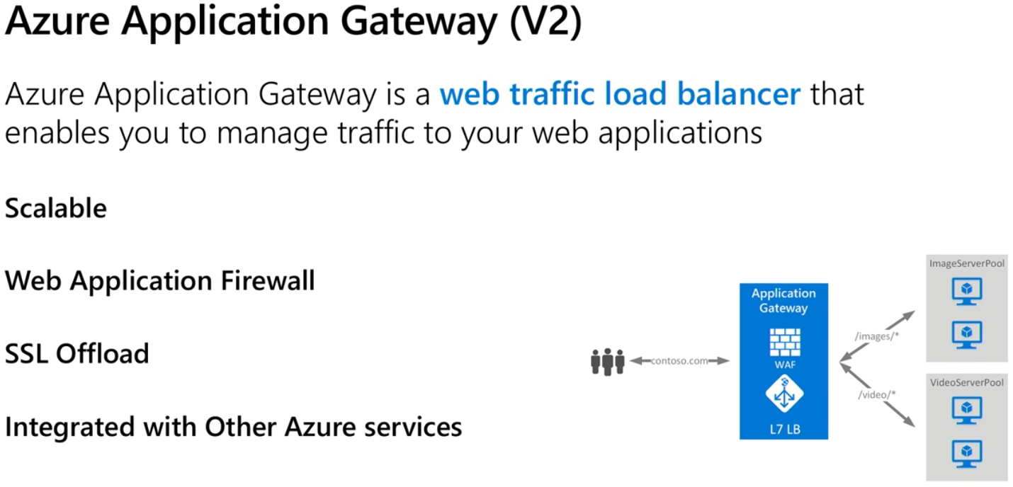

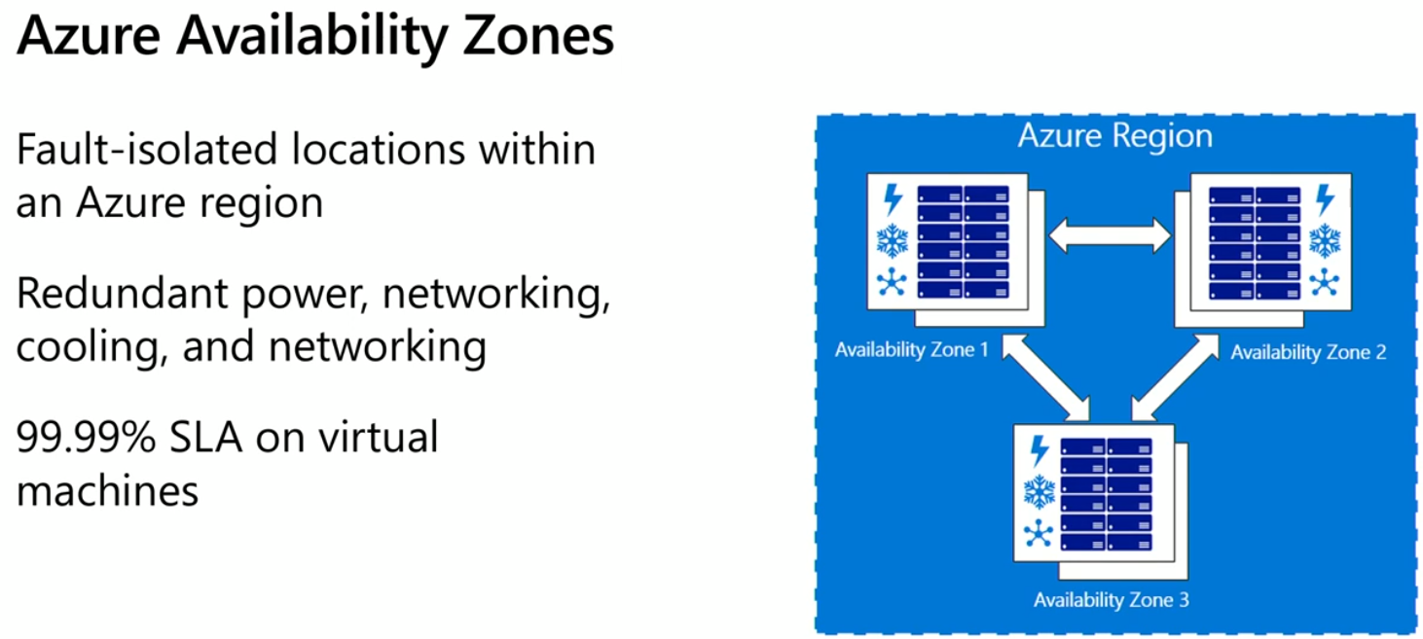  
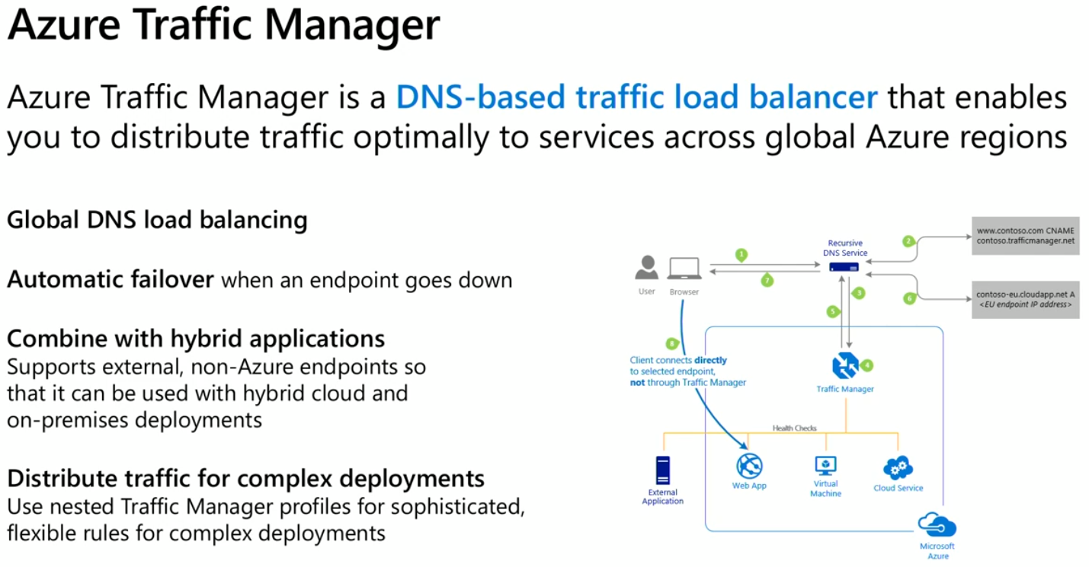  
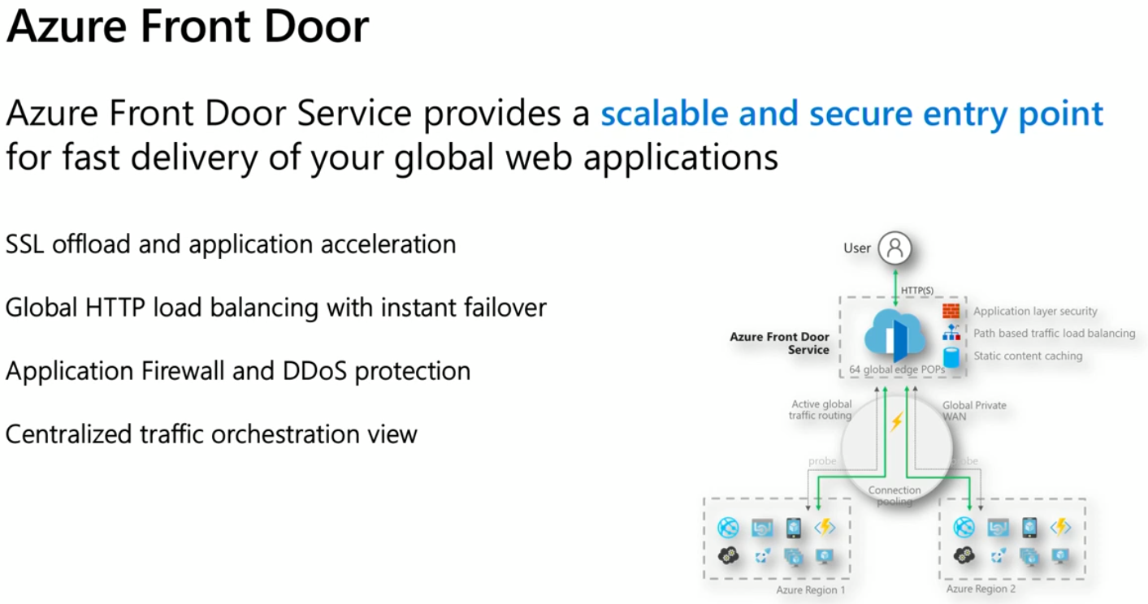  
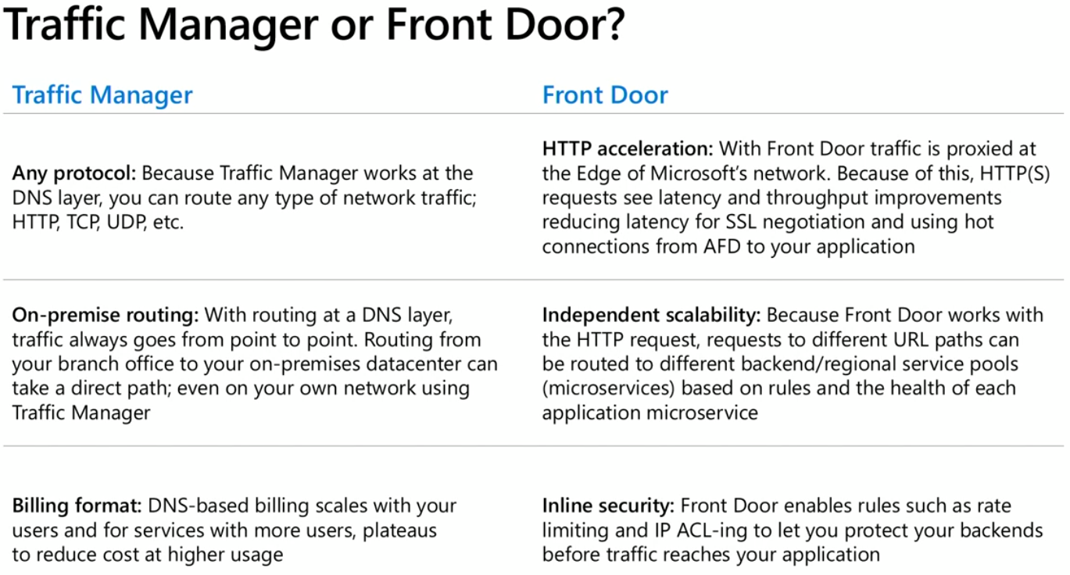

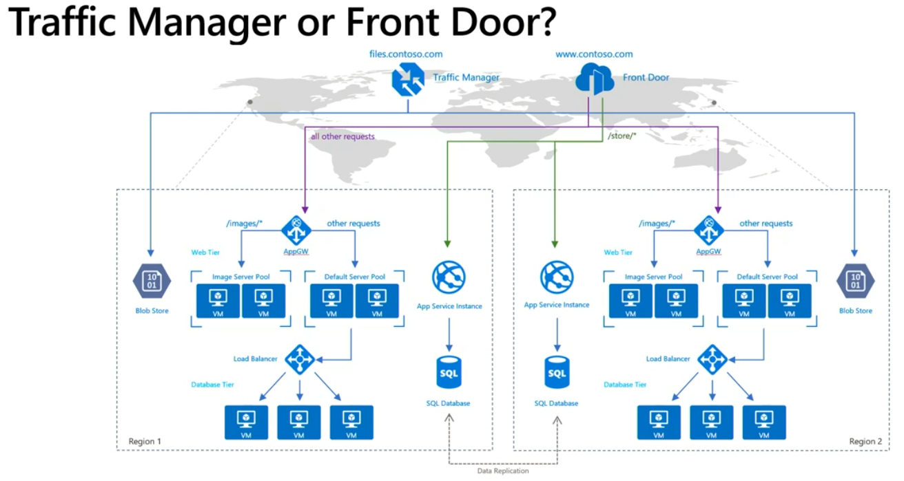  
Storage  
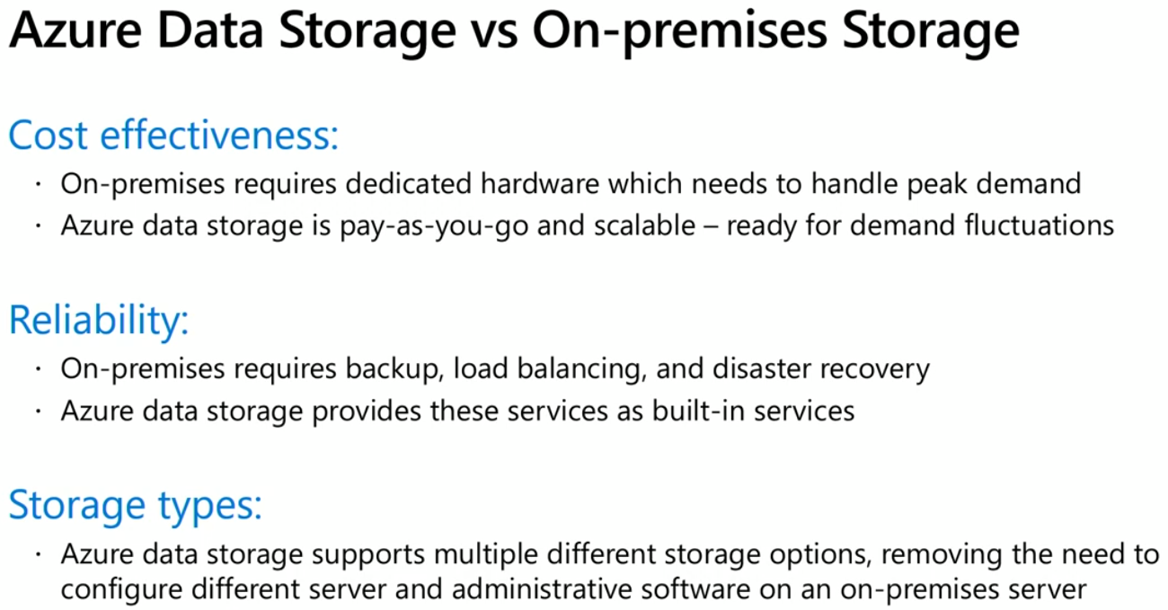  
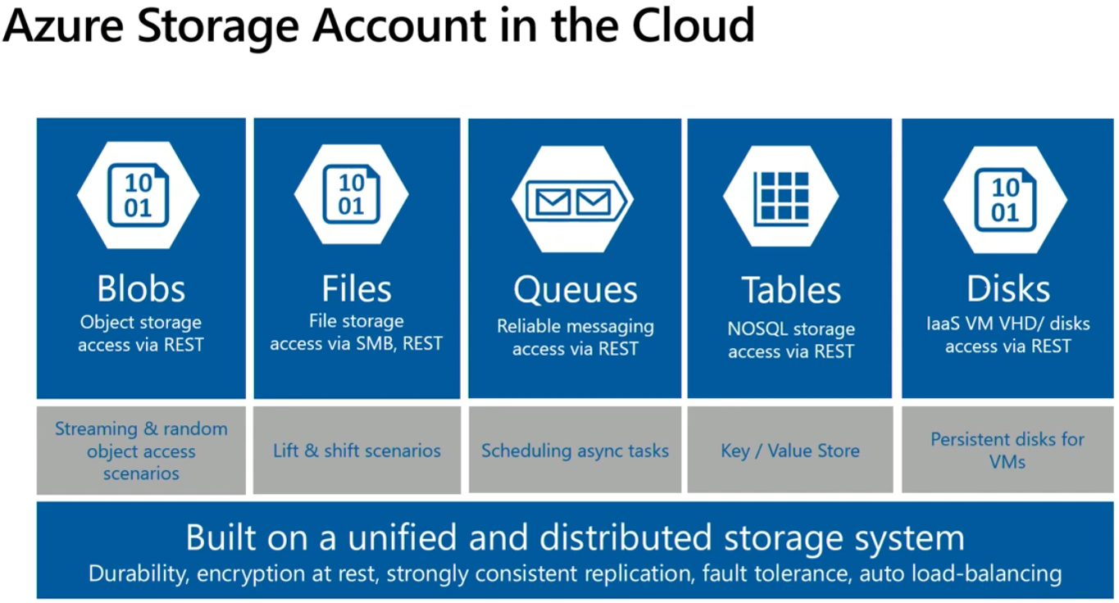  
8T storage size in Blobs  
Structured storage of files in Files  
64K max message size in Queue. Very good for On-Premise and Azure communication.  
NOSQL Key/Value pairs in Tables  
Persistent Disks for VMs   
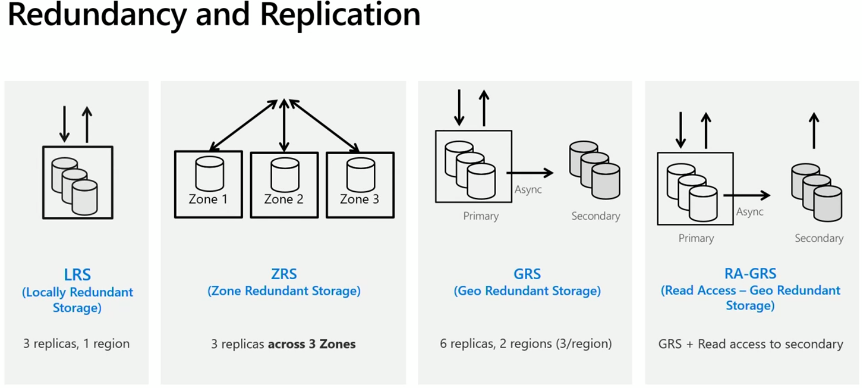  
LRS is replication within the same region any may happen within same building but another floor. There is no guarantee where the replication happens, but it is 3 copies altogether and within one region.  
ZRS as well is within the same region but individual 3 different zones. Generally 3 different data centres within same campus.  
GRS is 3 replicas in total as in LRS but also 3 more replicas in addition to LRS. These 3 more replicas are done in another region. So totally, 6 replicas are maintained across regions. The replication between The Primary region and secondary region will be async. Reads and Writes happen only from Primary region.  
RA-GRS is same as GRS, In addition we allow reads to happen on secondary region replications as well. So 6 replicas to read.  
On storage Account, Standard or Premium Performance? Hot Data or Cool Data?  
Hot Data means we want instant replication  
Cool Data means we are ok to do little late too, Nothing would fail.  
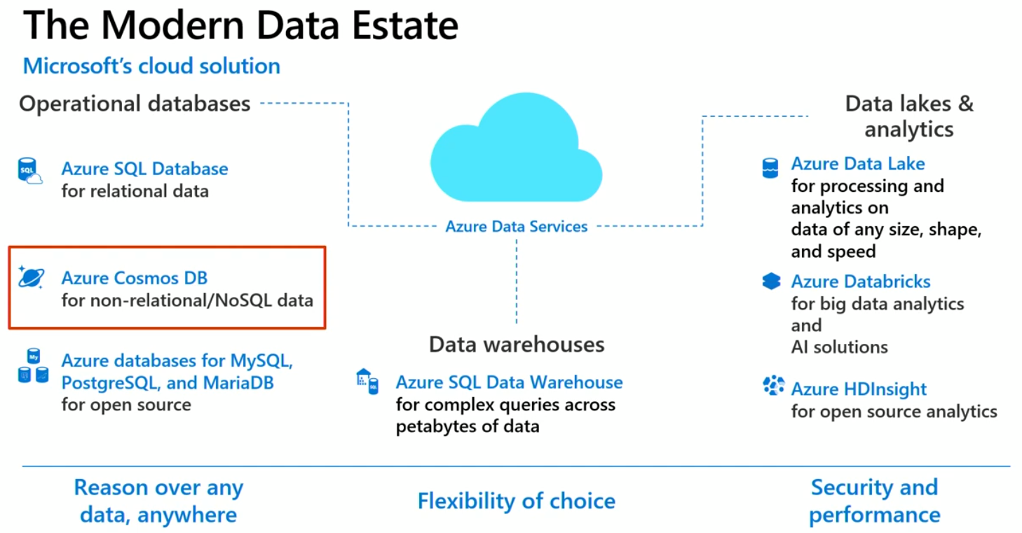  
  
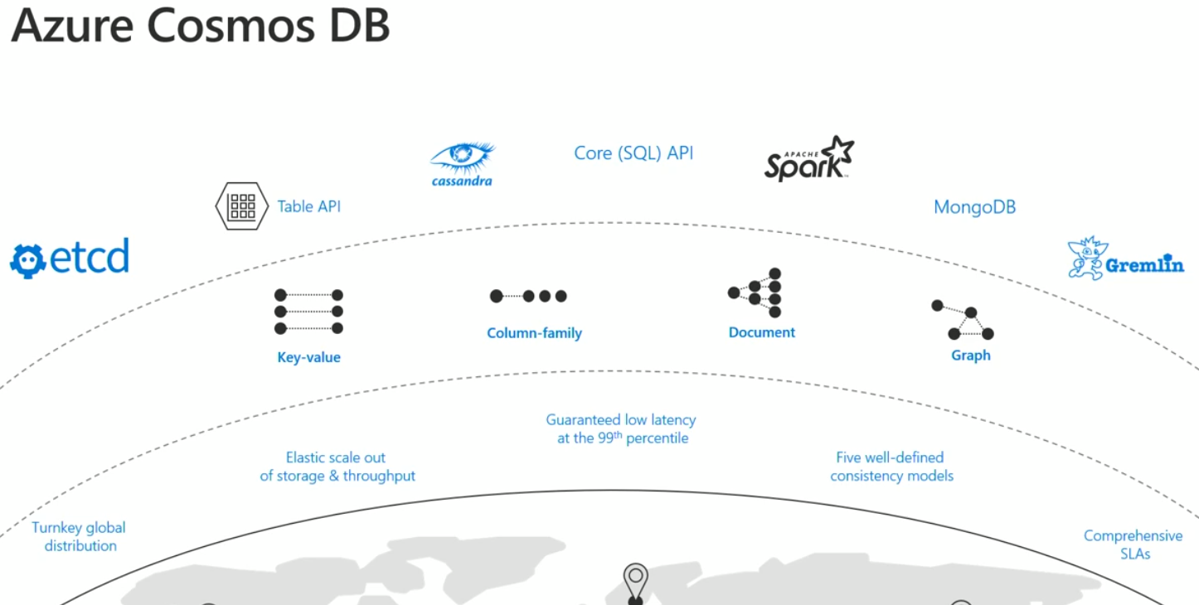  
  
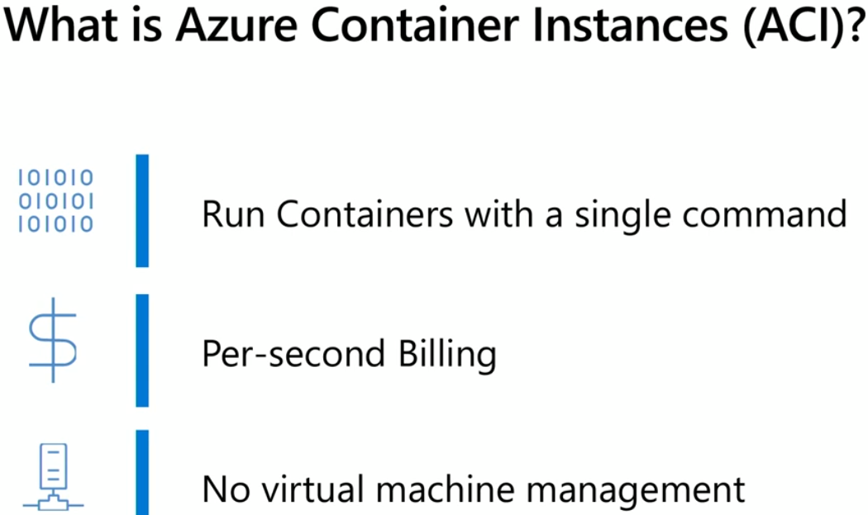  
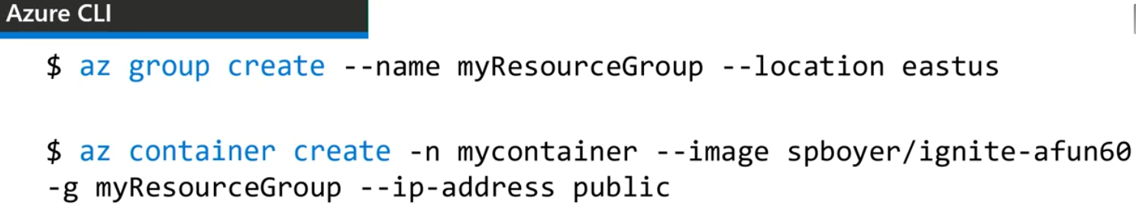  
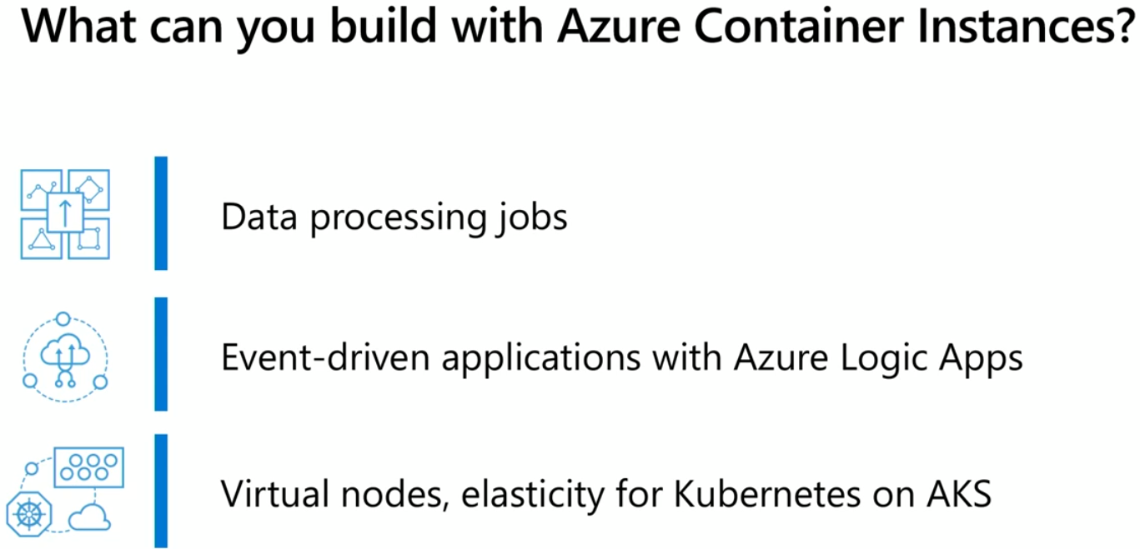  
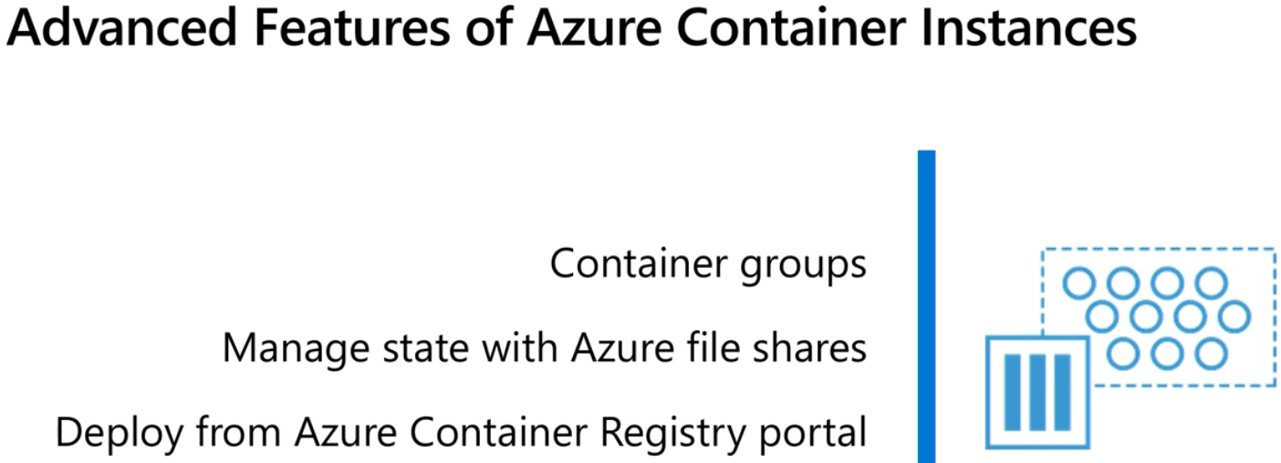

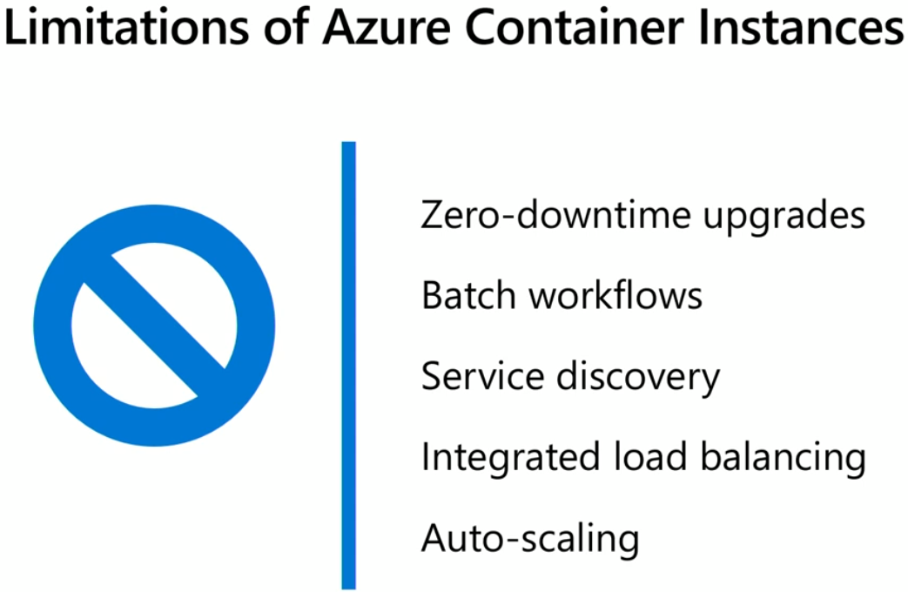  
Learn ACI  
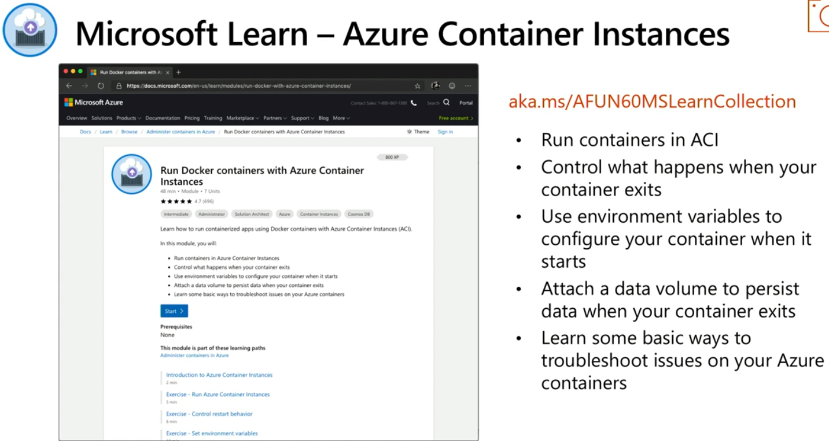  
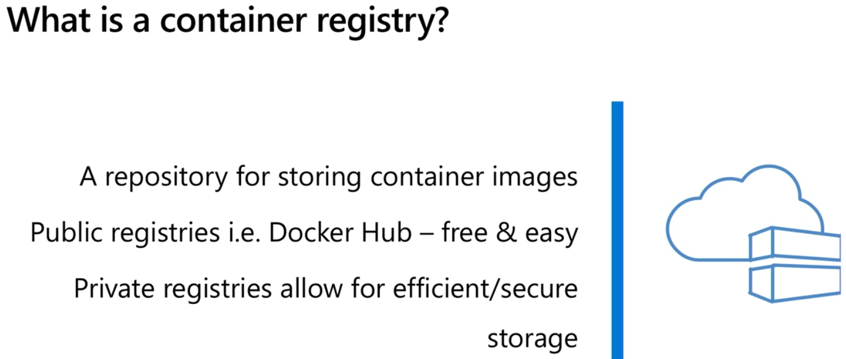  
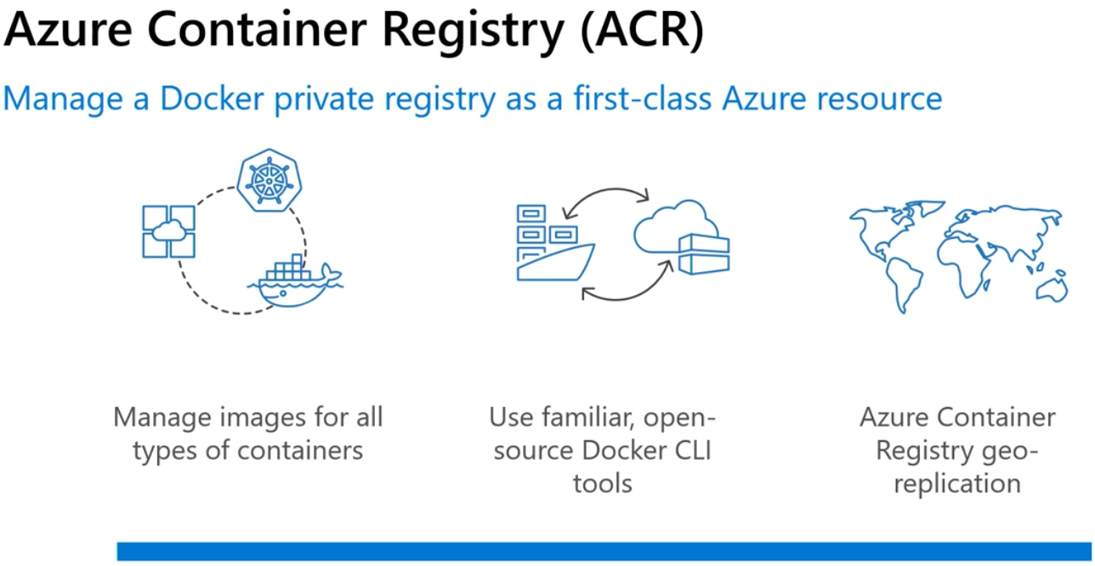

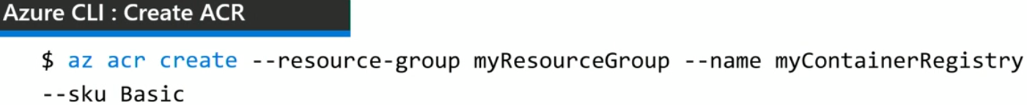  
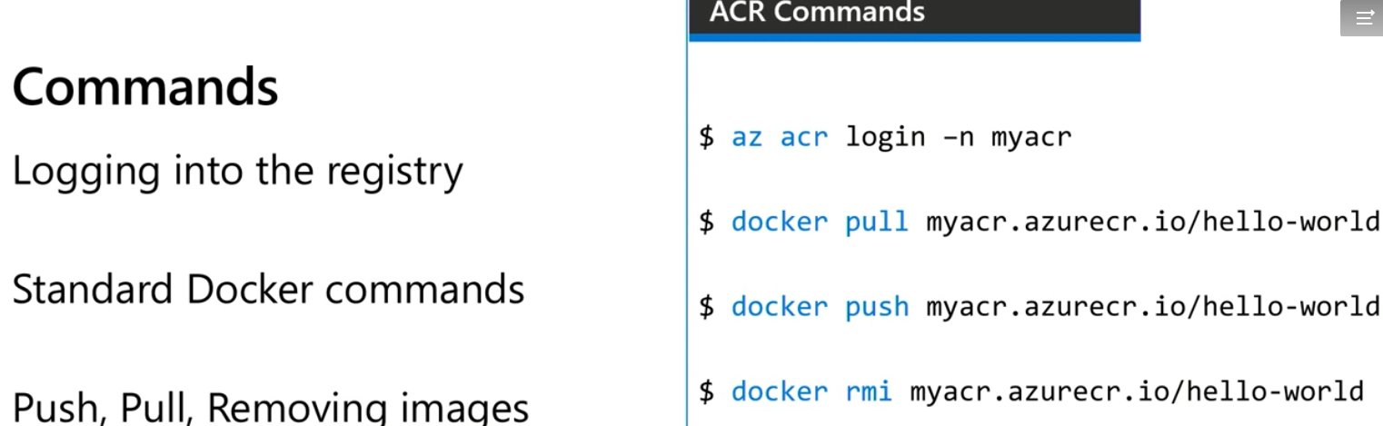  
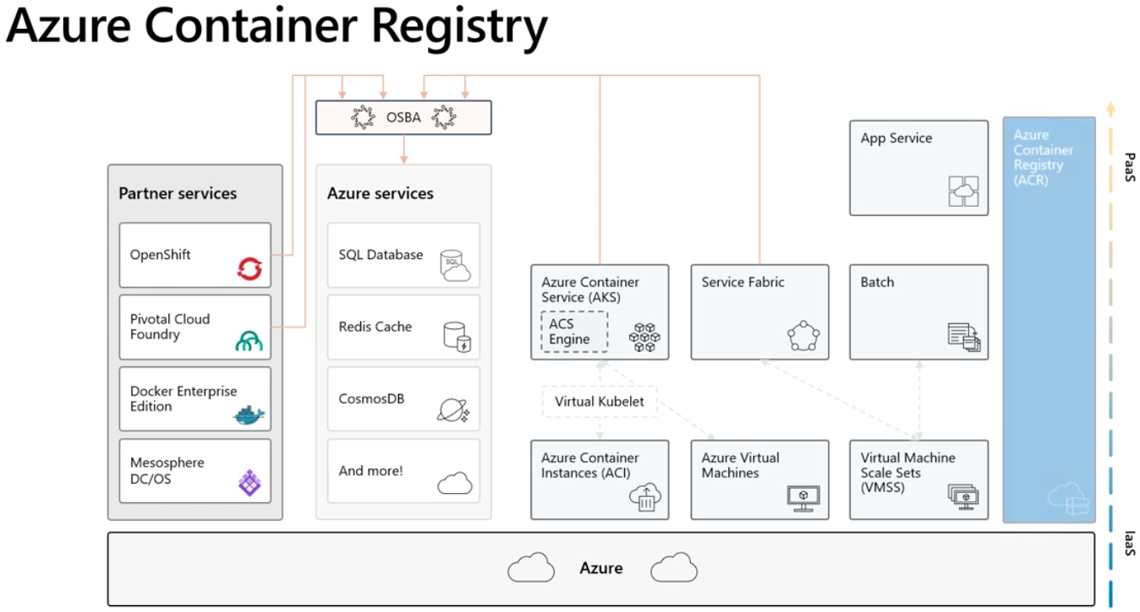  
Learn ACR  
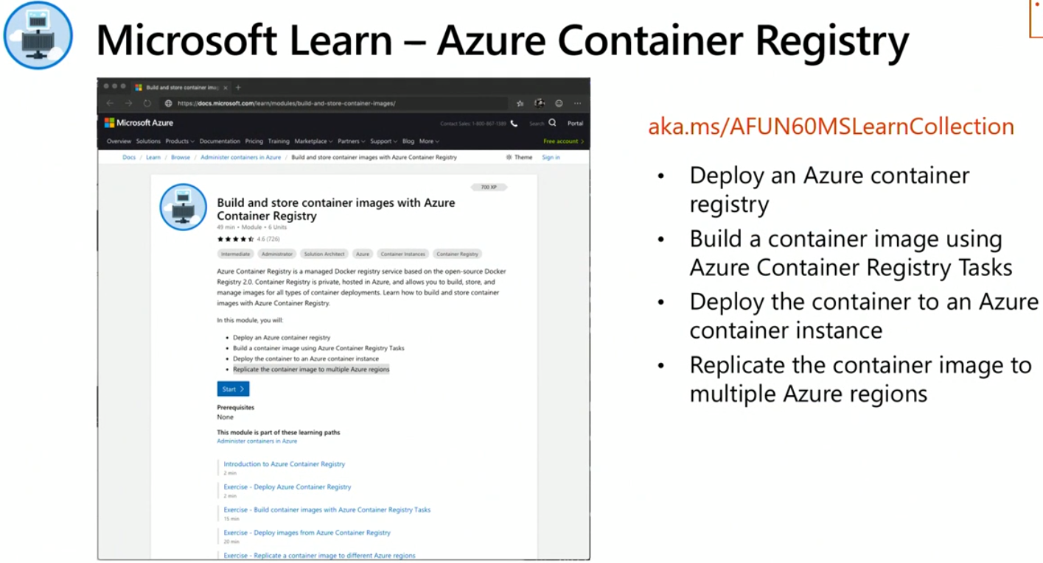

What do Egress and Ingress mean in the cloud?

Egress in the world of networking implies traffic that exits an entity or a network boundary, while Ingress is traffic that enters the boundary of a network. While in service provider types of the network this is pretty clear, in the case of datacenter or cloud it is slightly different. In the cloud, Egress still means traffic that’s leaving from inside the private network out to the public internet, but Ingress means something slightly different. To be clear private networks here refers to resources inside the network boundary of a data center or cloud environment and its IP space is completely under the control of an entity who operates it.

Since traffic often is translated using NAT in and out of a private network like the cloud, a response back from a public endpoint to a request that was initiated inside the private network is not considered Ingress. If a request is made from the private network out to a public IP, the public server/endpoint responds back to that request using a port number that was defined in the request, and firewall allows that connection since its aware of an initiated session based on that port number. See picture below for reference.

Egress:

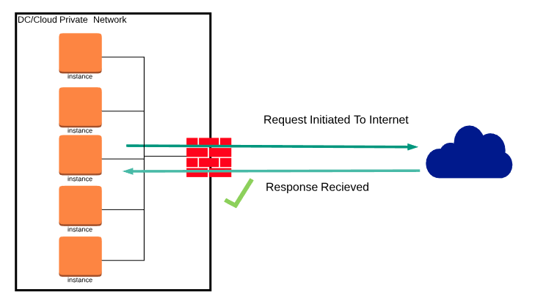

With Egress out of the way, let's define Ingress. As you might be guessing by now, Ingress refers to unsolicited traffic sent from an address in public internet to the private network – it is not a response to a request initiated by an inside system. In this case, firewalls are designed to decline this request unless there are specific policy and configuration that allows ingress connections. See picture below for reference.  
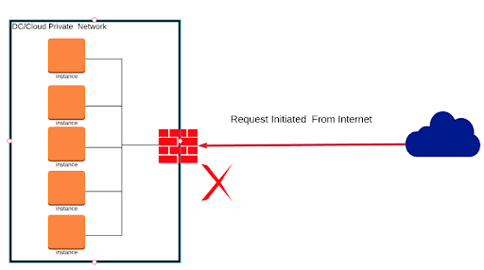  
  
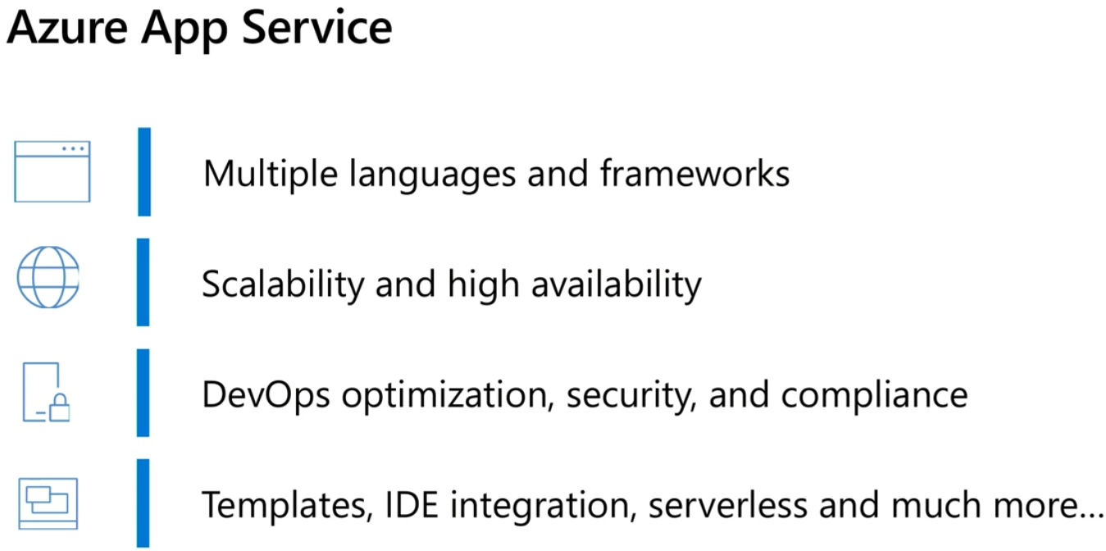  
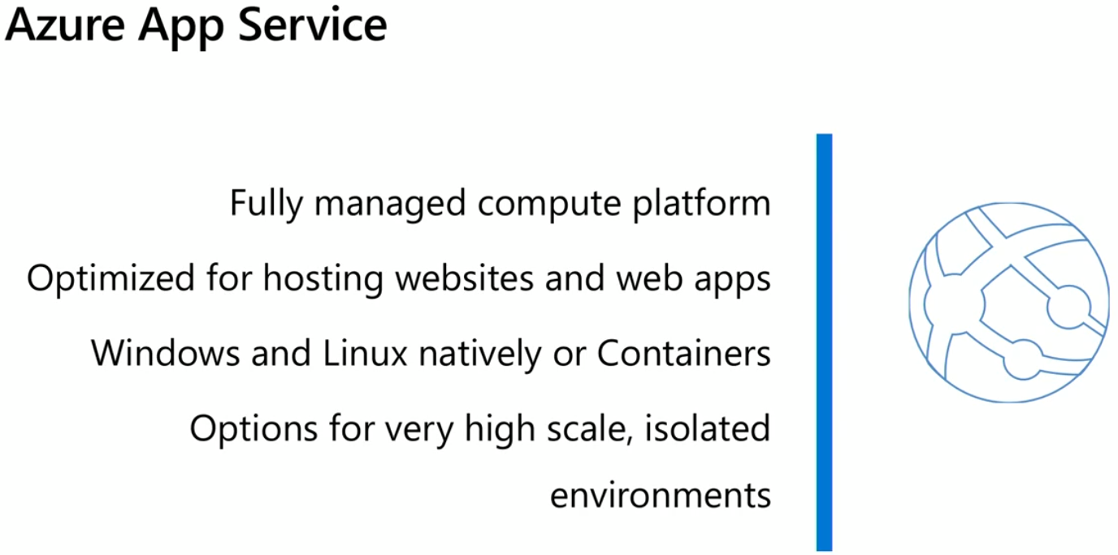  
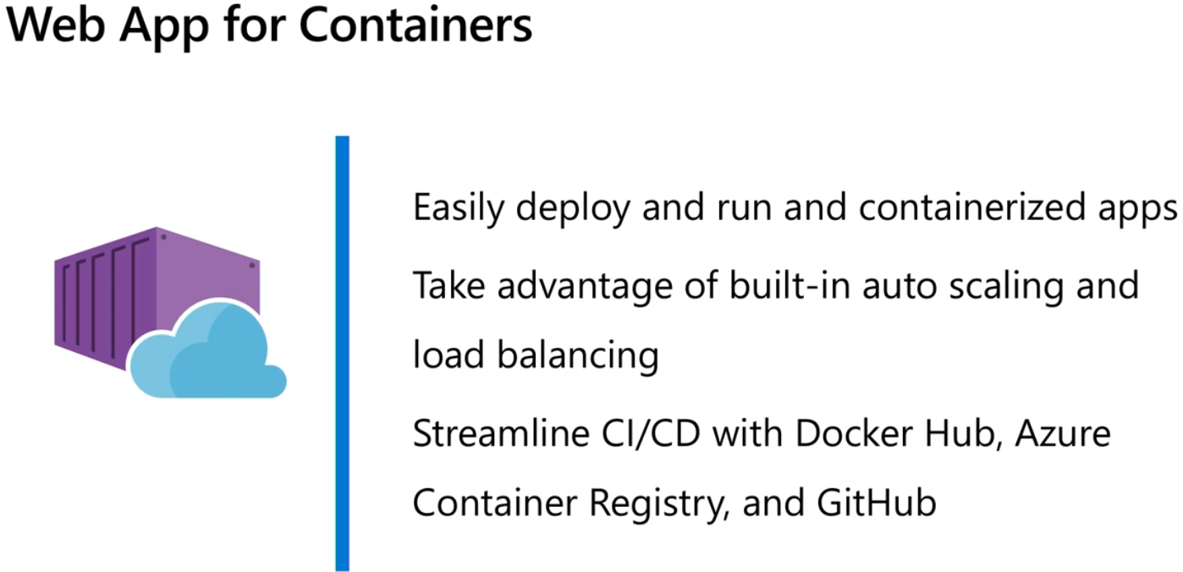  
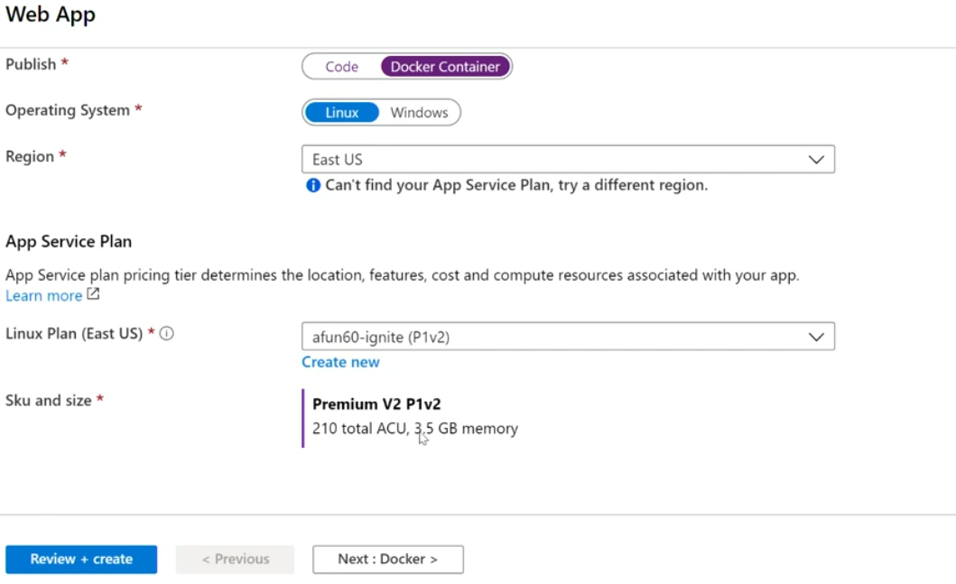  
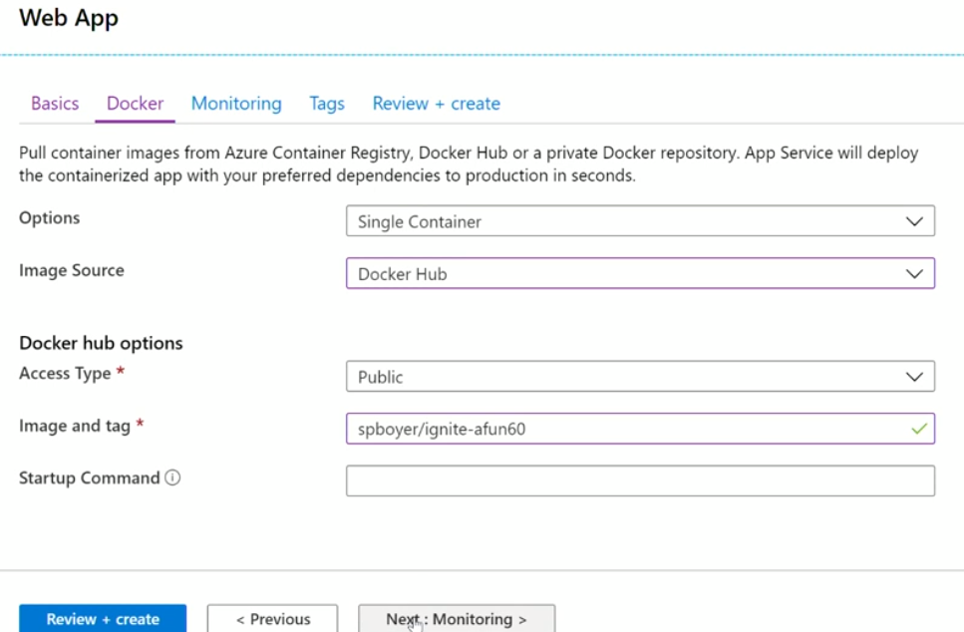  
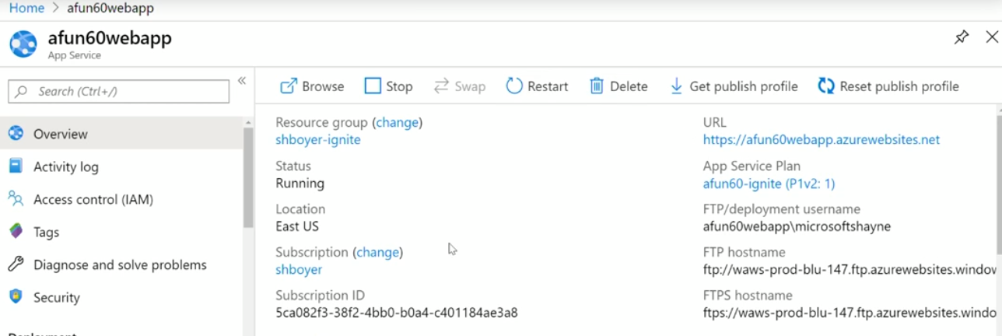  
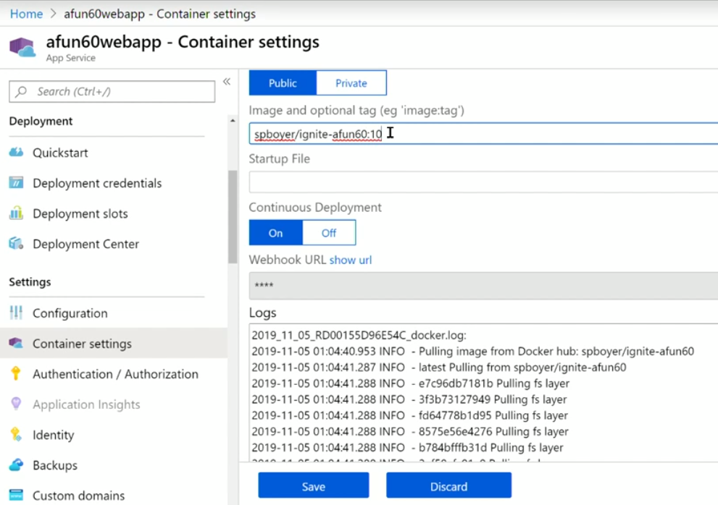  
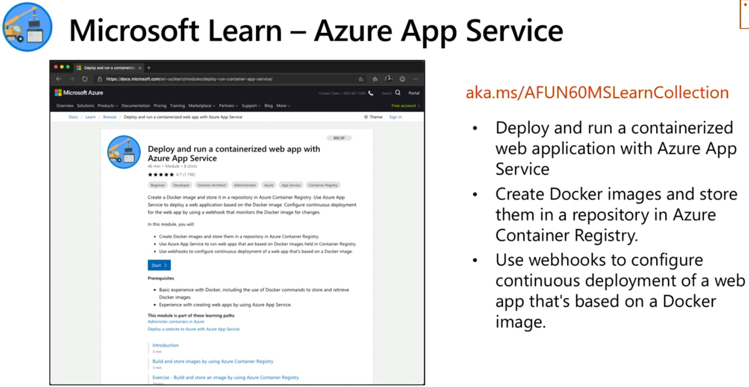  
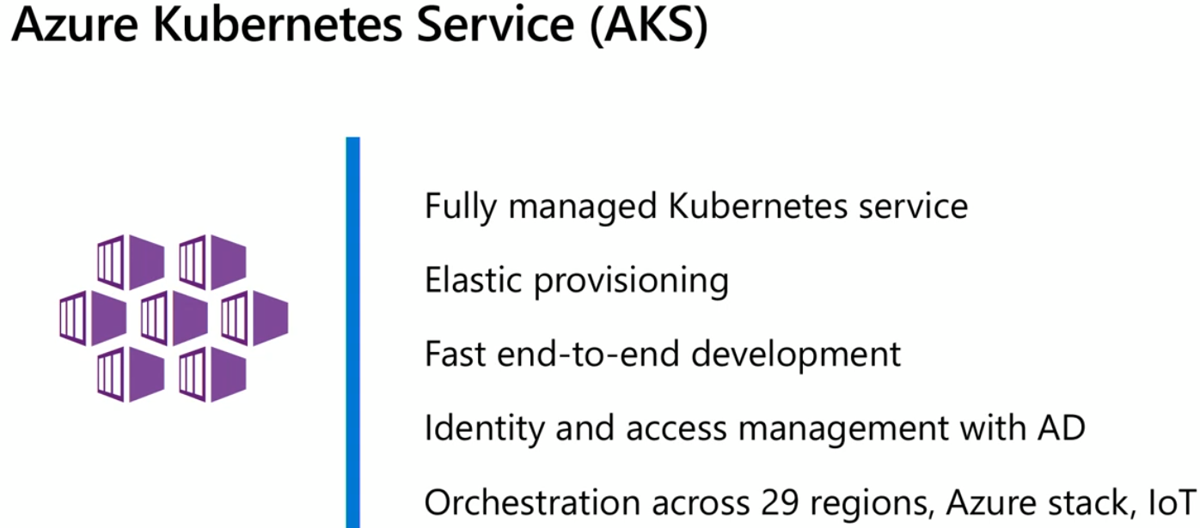  
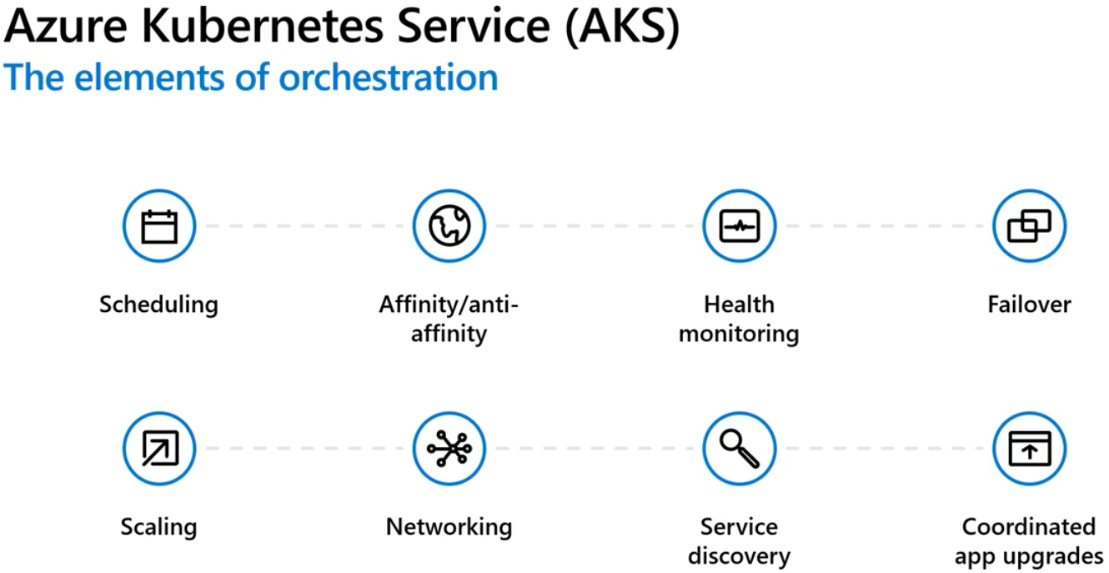  
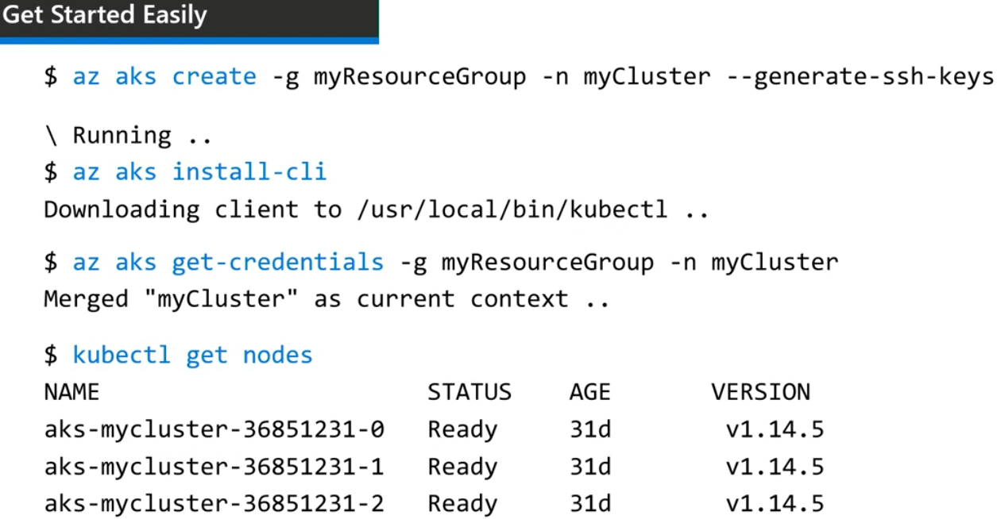  
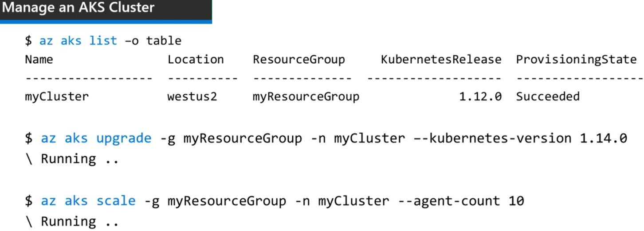  
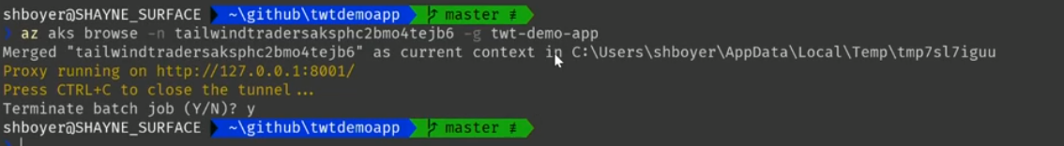  
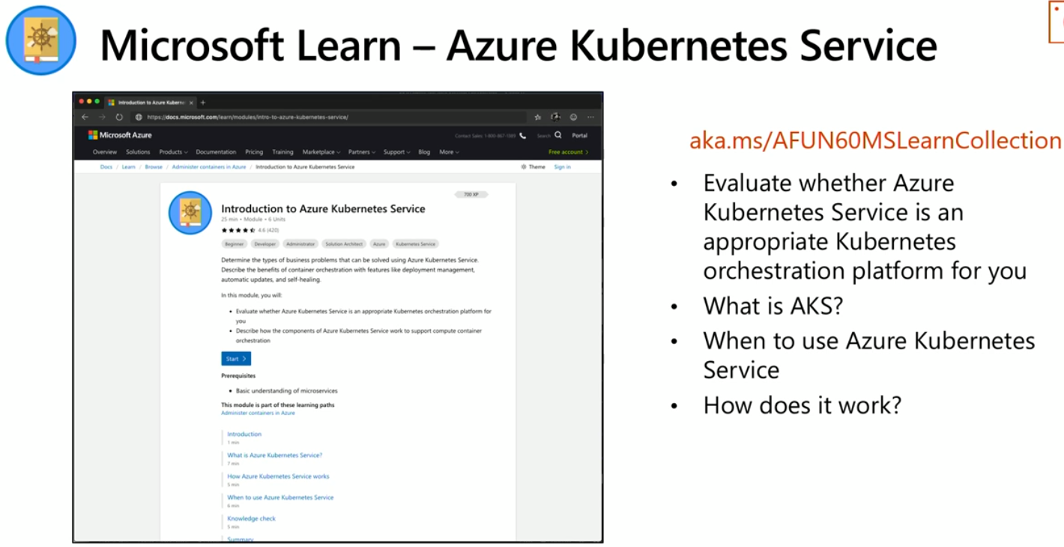  
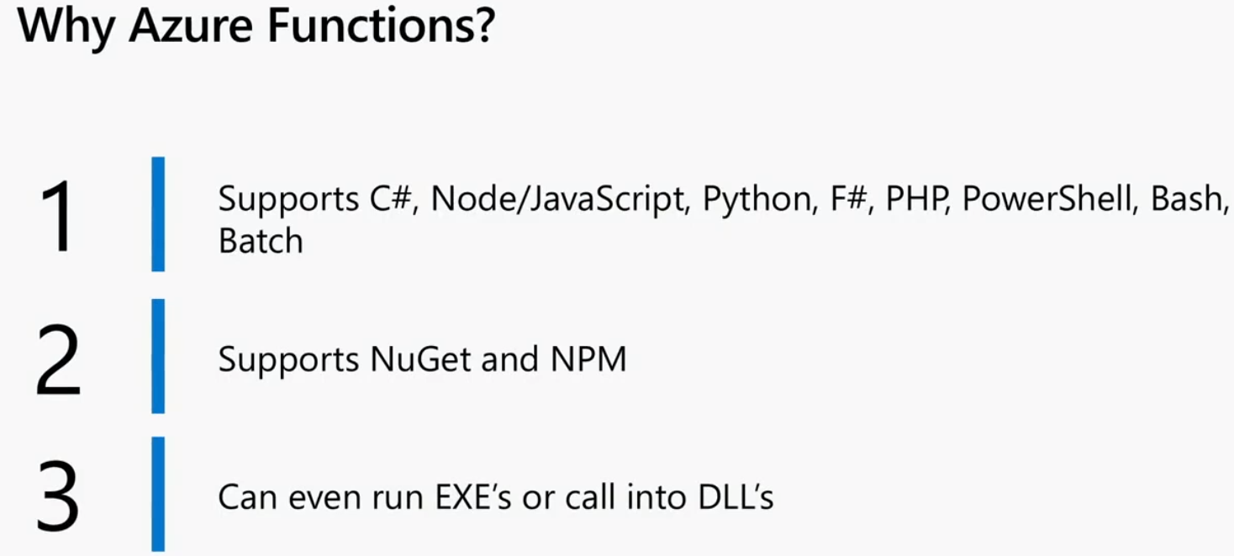  
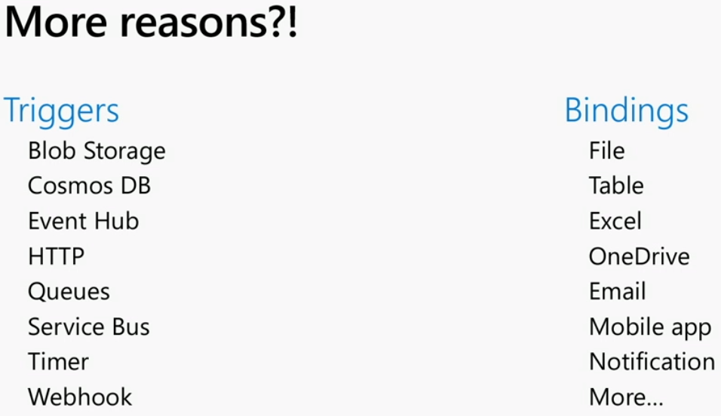  
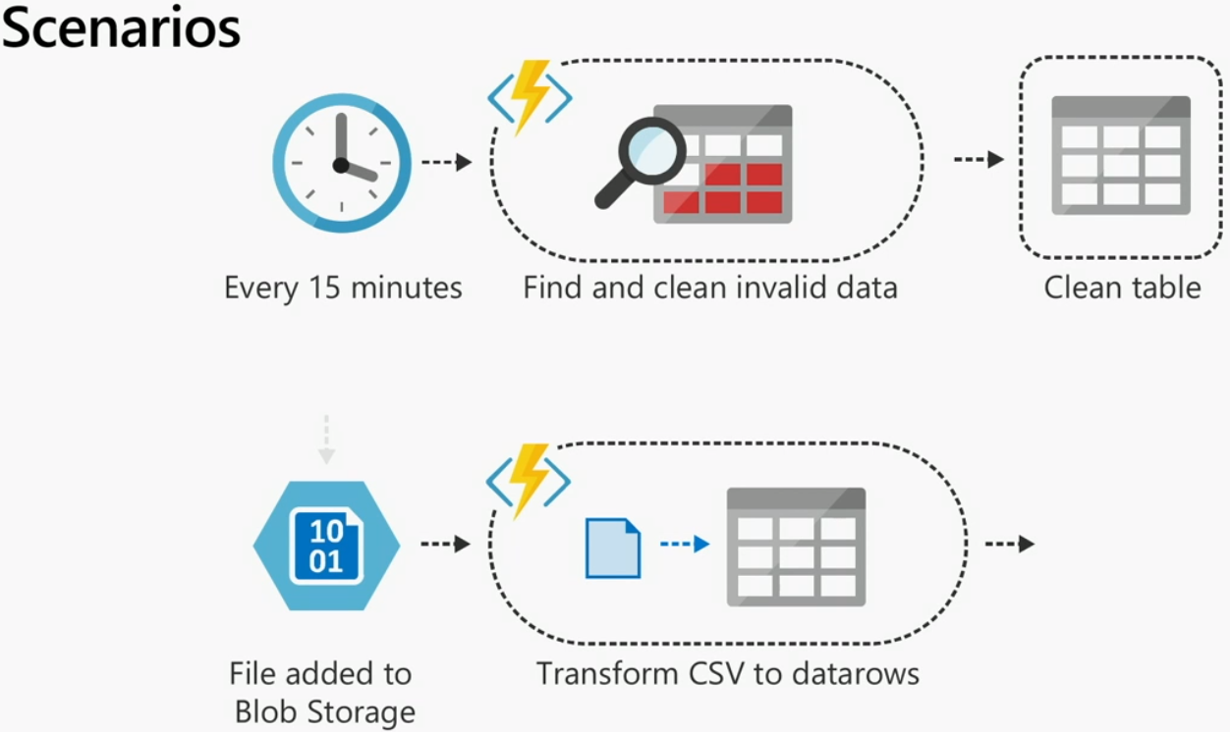  
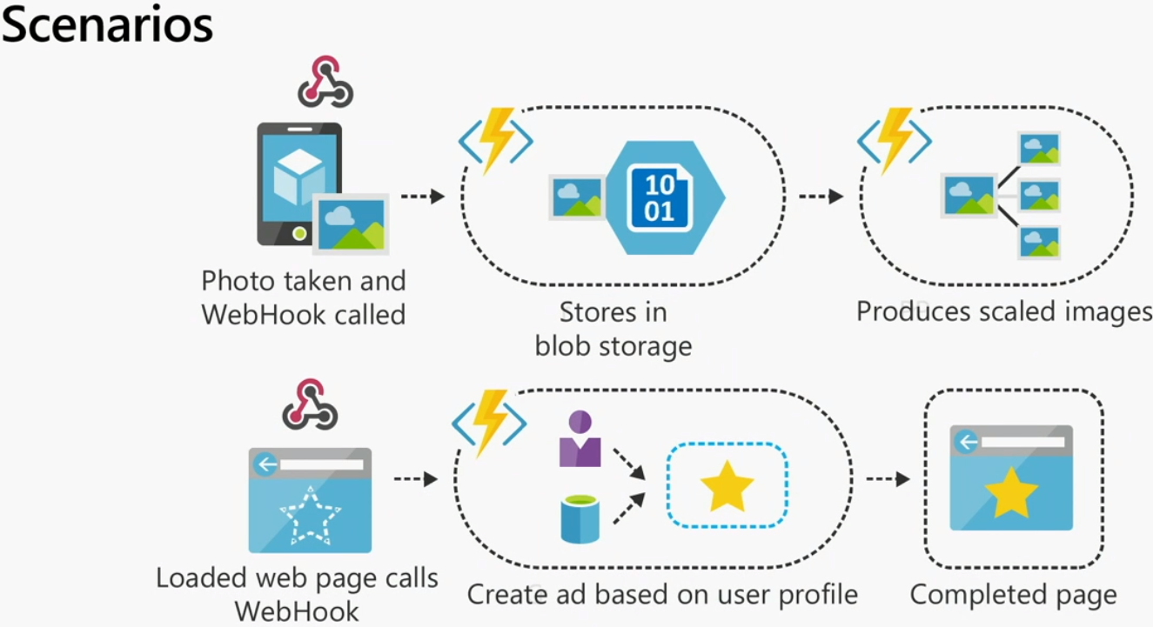  
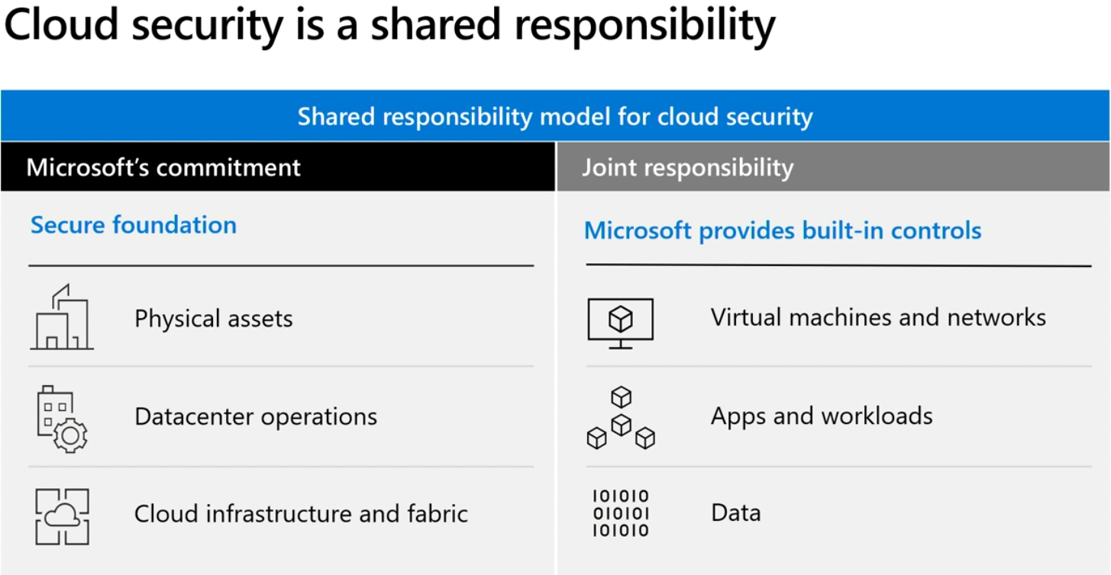  
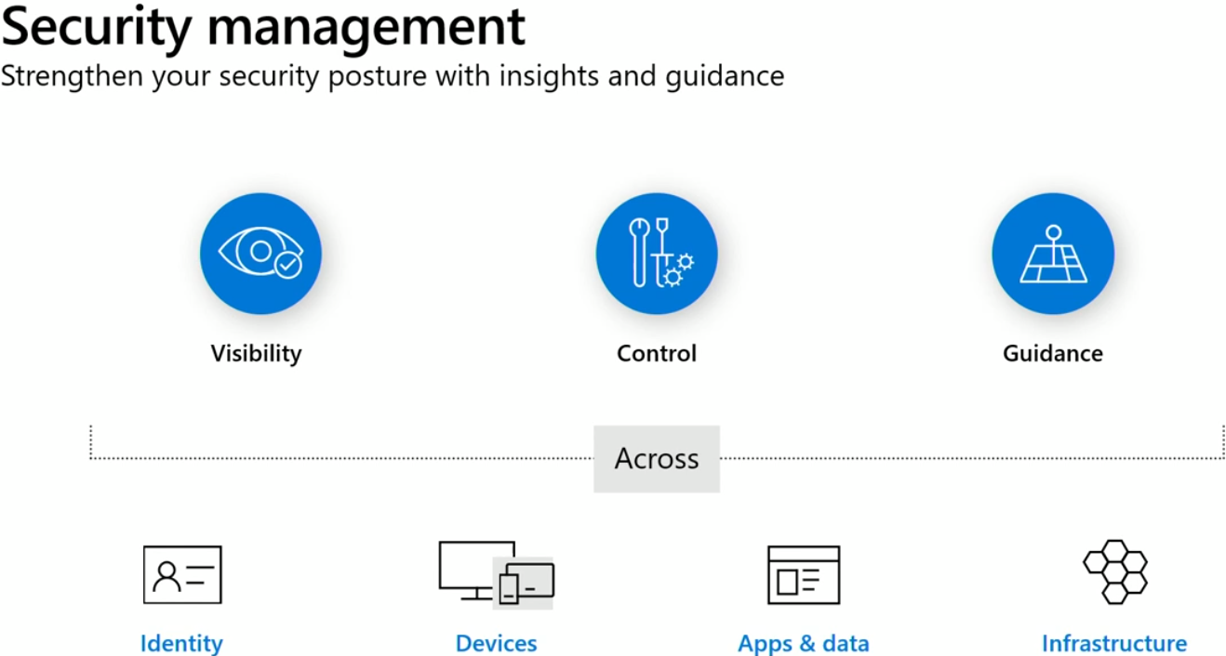  
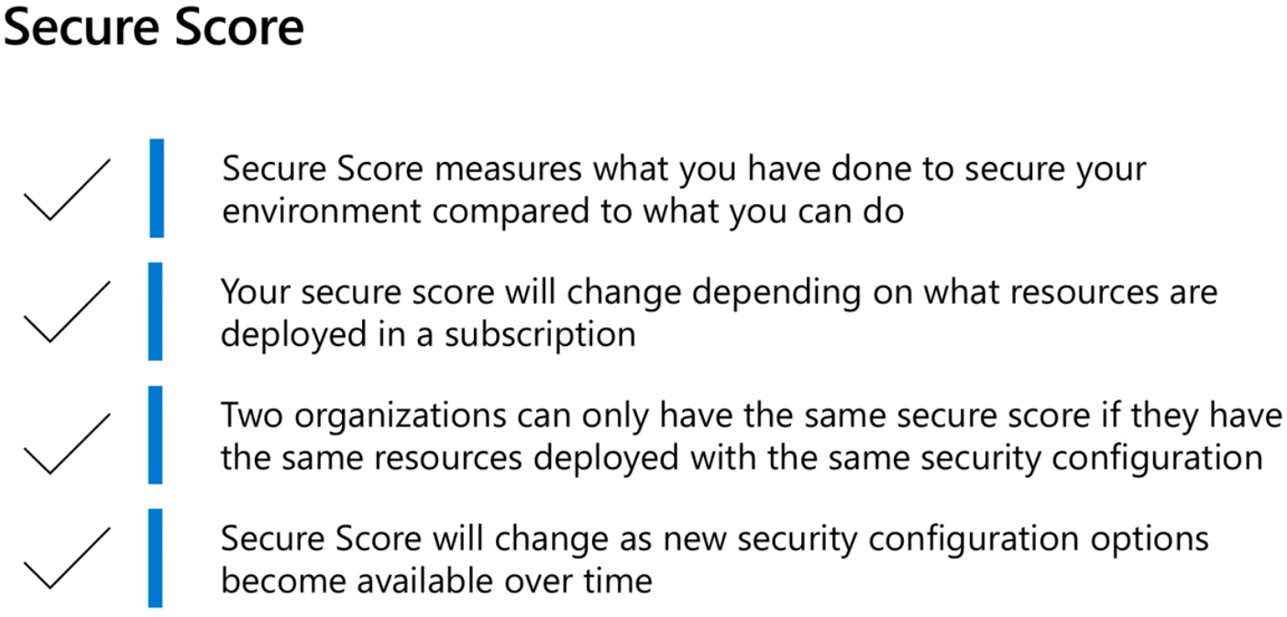  
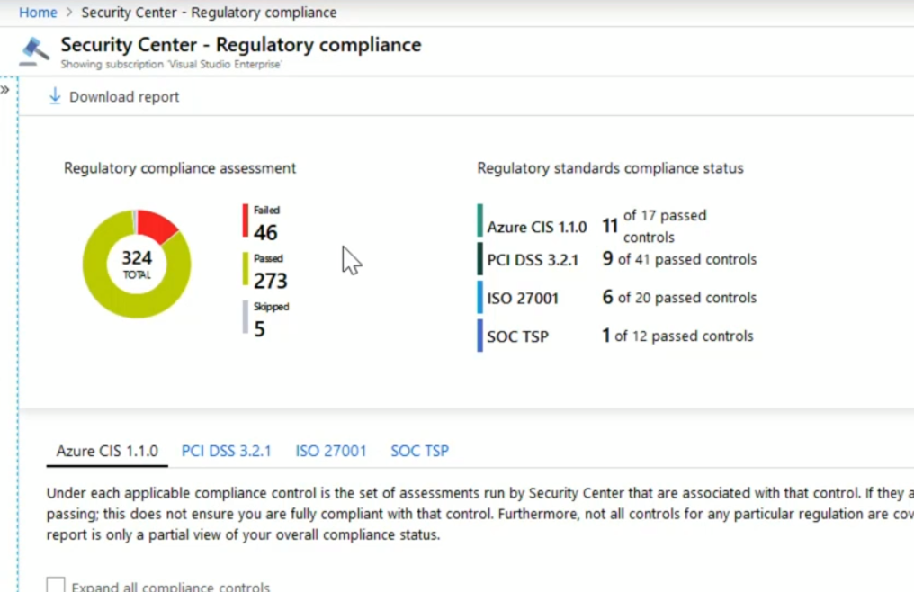  
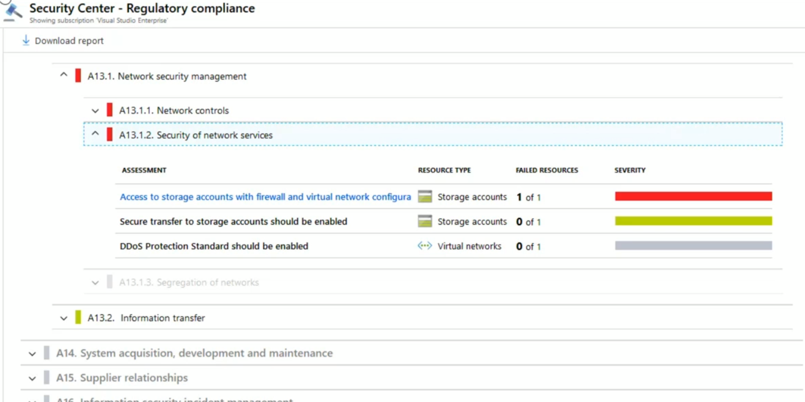  
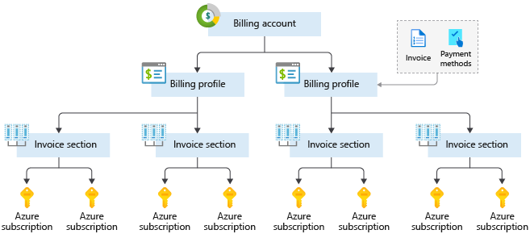

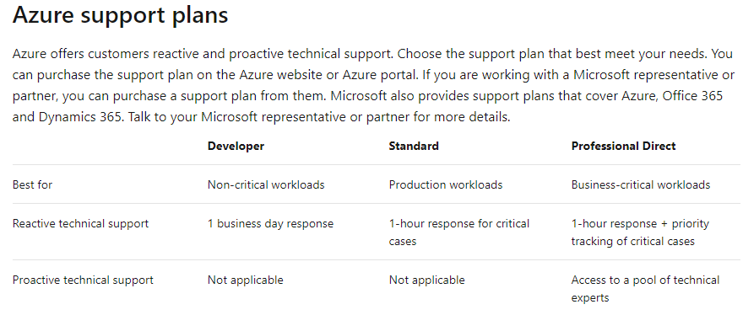  
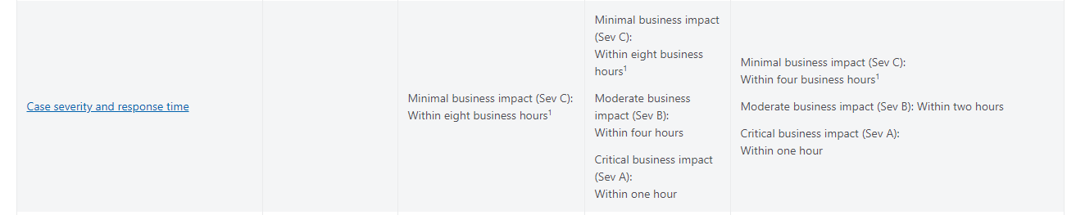  
https://azure.microsoft.com/support/plans/  
Current subscription in table format  
az account list --output table  
Resource groups  
az group list --output table  
List the resource inside given resource group. And filter the resources to contain only web sites.  
az resource list \  
 --resource-group learn-36bbfbd9-8fe8-480c-9582-3d9f3da61180 \  
 --resource-type Microsoft.Web/sites  
Stop the web app resource  
az webapp stop \  
 --resource-group learn-36bbfbd9-8fe8-480c-9582-3d9f3da61180 \  
 --name TezWP  
<http://tezwp.azurewebsites.net/> is not running now as the Wordpress web app created from the Azure portal is stopped.  
Start the web app resource now  
az webapp stop \  
 --resource-group learn-36bbfbd9-8fe8-480c-9582-3d9f3da61180 \  
 --name TezWP  
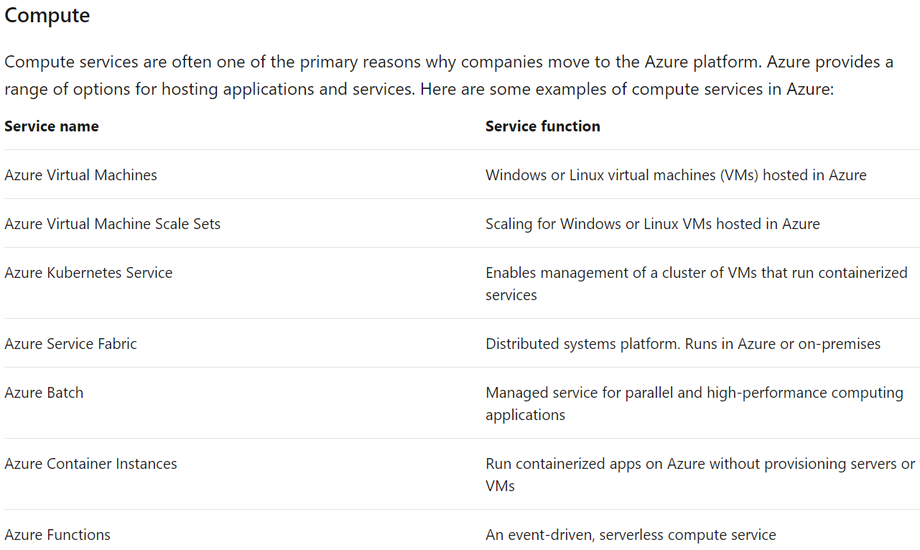

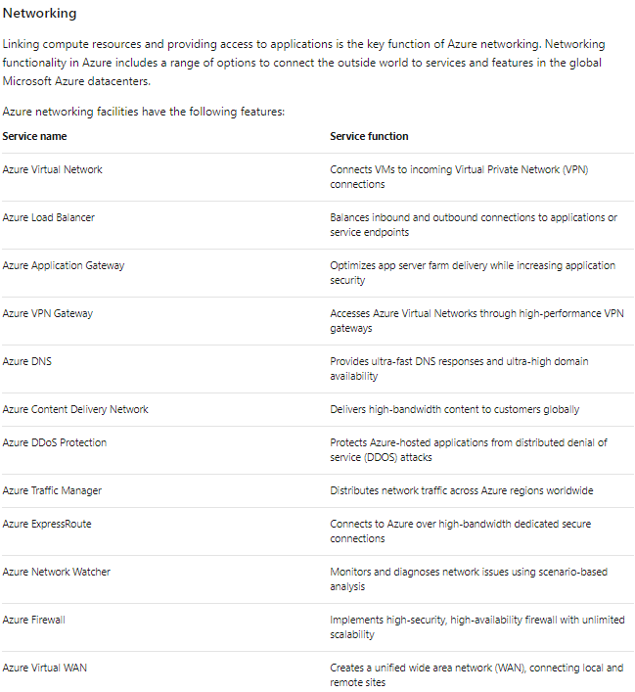

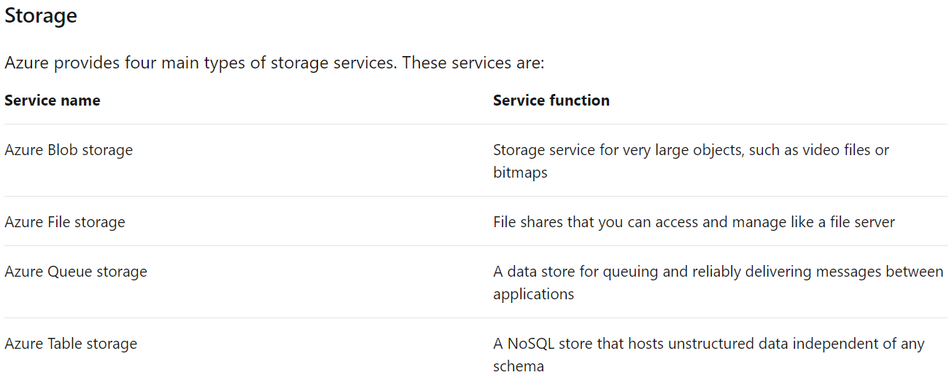  
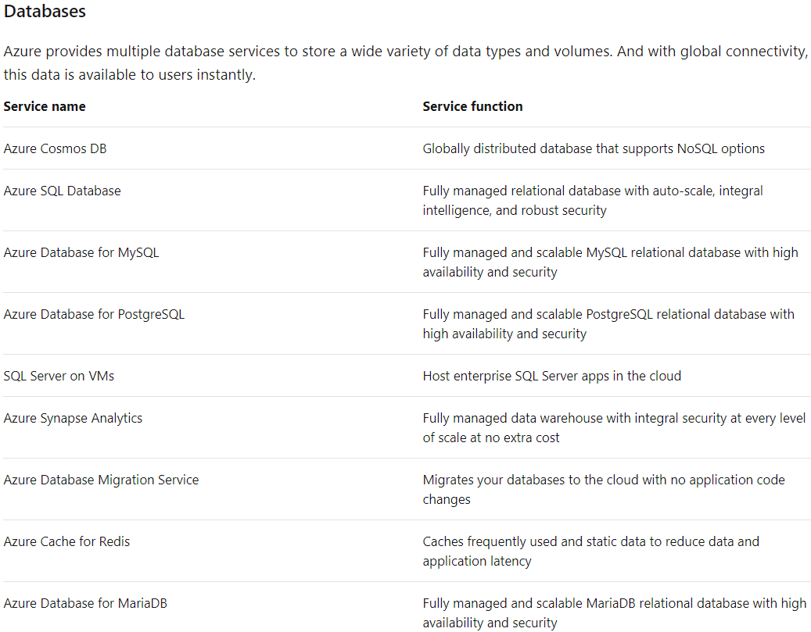  
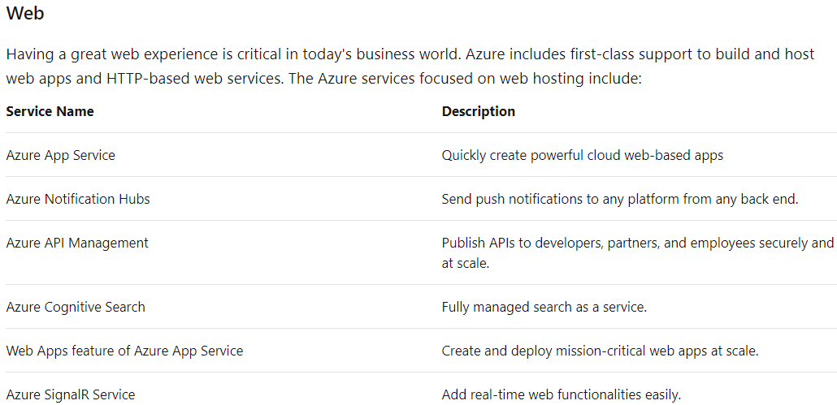  
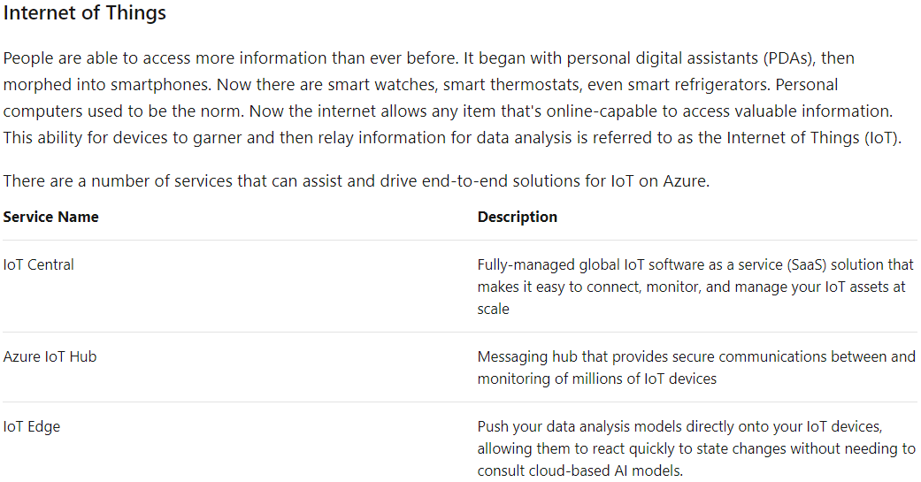  
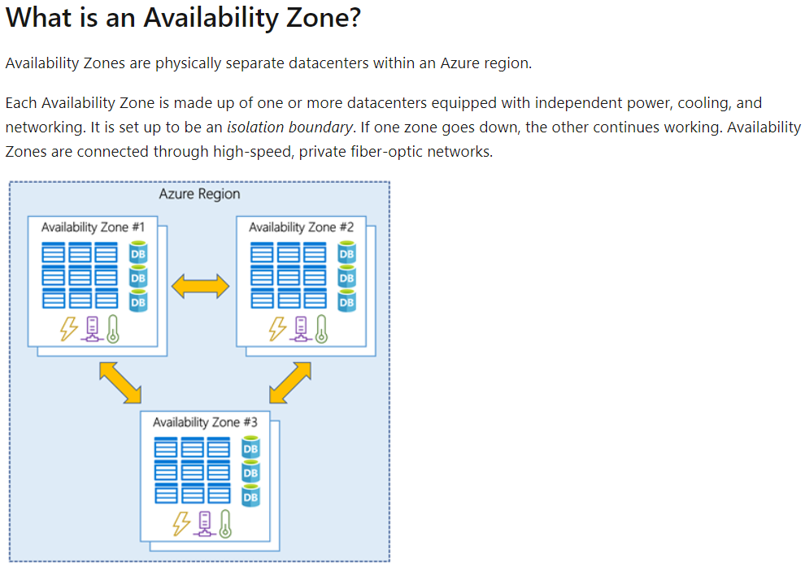  
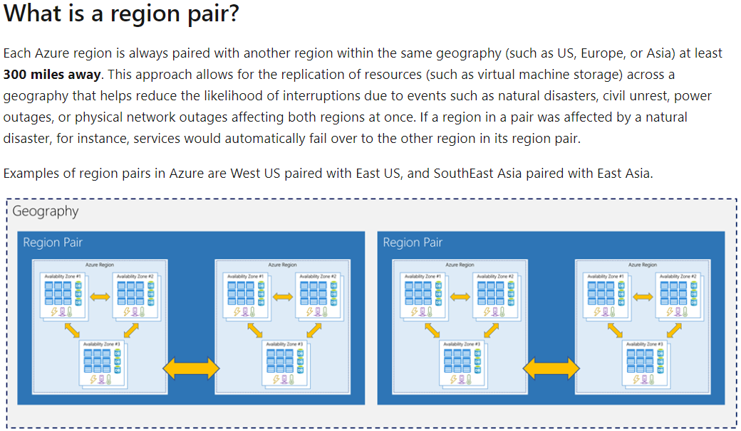  
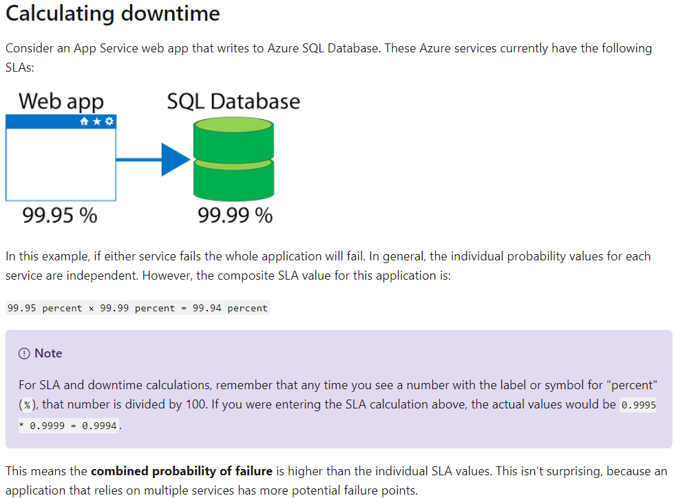

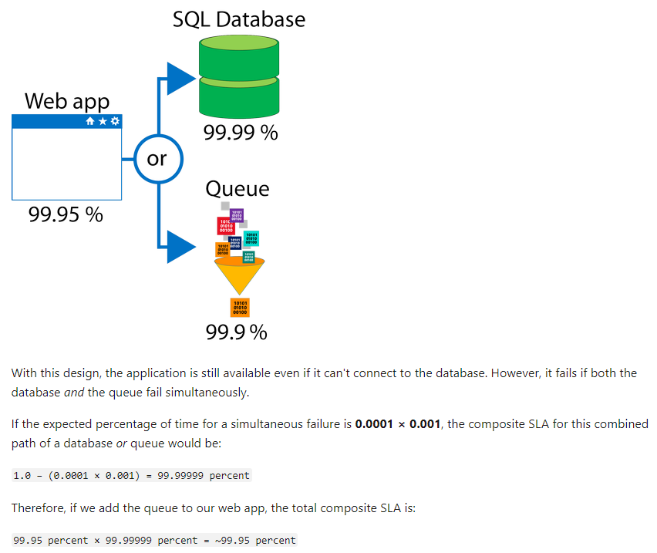

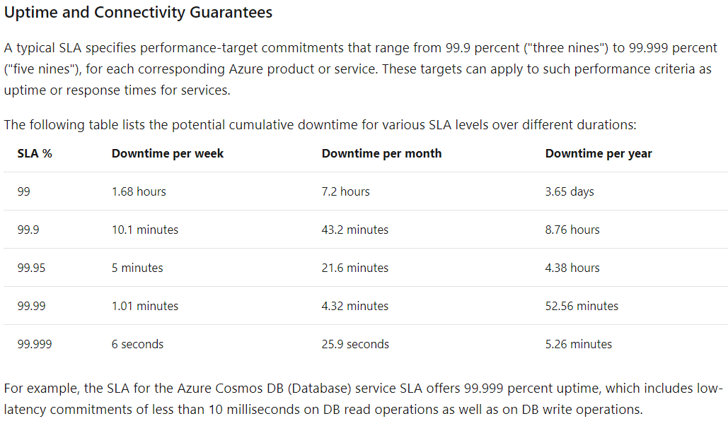  
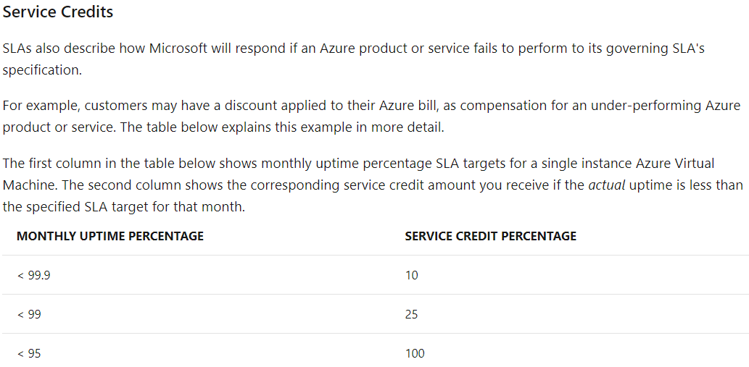

**A *virtual network*** is a logically isolated network on Azure. Azure virtual networks will be familiar to you if you've set up networks on Hyper-V, VMware, or even on other public clouds. A virtual network allows Azure resources to securely communicate with each other, the internet, and on-premises networks. **A virtual network is scoped to a single region**; however, multiple virtual networks from different regions can be connected together using **virtual network peering**.

Virtual networks can be segmented into one or more subnets. Subnets help you organize and secure your resources in discrete sections. The web, application, and data tiers each have a single VM. All three VMs are in the same virtual network but are in separate subnets.

Users interact with the web tier directly, so that VM has a public IP address along with a private IP address. Users don't interact with the application or data tiers, so these VMs each have a private IP address only.

You can also keep your service or data tiers in your on-premises network, placing your web tier into the cloud, but keeping tight control over other aspects of your application. **A VPN gateway** (or virtual network gateway), enables this scenario. It can provide a secure connection between an Azure Virtual Network and an on-premises location over the internet.

Azure manages the physical hardware for you. You configure virtual networks and gateways through software, which enables you to treat a virtual network just like your own network. You choose which networks your virtual network can reach, whether that's the public internet or other networks in the private IP address space.

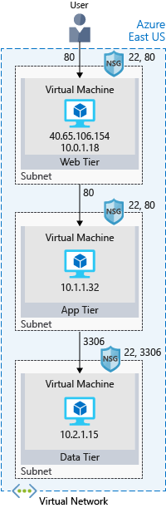**Encryption**Symmetric – One key to encrypt and decrypt.  
Asymmetric – Private & Public key. Both keys can encrypt but only one (private) can decrypt.  
  
**Encryption at Rest** – On devices  
**Encryption on Transit –** During data transfer  
  
**Encrypt raw storage - Azure Storage Service Encryption -** automatically encrypts your data before persisting it to Azure Managed Disks, Azure Blob storage, Azure Files, or Azure Queue storage, and decrypts the data before retrieval.

**Encrypt virtual machine disks** - Azure Storage Service Encryption is for physical disks but not for virtual hard disks (VHDs). **Azure Disk Encryption** - **Bitlocker** on windows and **dm-crypt** for Linux is used.

**Encrypt Database – Transparent Data Encryption (TDE) –** Default key per DB is provided. Bring your own key (BYOK) is also supported and can be stored in Azure Key Vault.  
**Encrypt Secrets** – **Azure Key Vault  
Azure Key Vault –** Secrets management like connection string, passwords, certificates. You can integrate Key Vault with storage accounts, container registries, event hubs, and many more Azure services. Because Azure AD identities can be granted access to use Azure Key Vault secrets, applications with managed service identities enabled can automatically and seamlessly acquire the secrets they need.

**Network Security**  
**Azure Firewall** – Limits to a range of inbound IP addresses and specific ports. Provides support for non-HTTPs traffic like **FTP, RDP, SSH**.  
**Azure Application Gateway** –**Load Balancer that Includes WAF -Web App Firewall** that deals with limiting the known HTTP vulnerabilities. Designed to protect **HTTP** traffic.  
**Network virtual appliances (NVAs)** – **non-HTTP** or advanced configurations or **hardware firewall appliances**

**Azure Blueprints**The Azure Blueprints service is designed to help with environment setup. This setup often consists of a set of resource groups, policies, role assignments, and Resource Manager template deployments. A blueprint is a package to bring each of these artifact types together and allow you to compose and version that package—including through a CI/CD pipeline. Ultimately, each setup is assigned to a subscription in a single operation that can be audited and tracked.

Nearly everything that you want to include for deployment in Blueprints can be accomplished with a Resource Manager template. However, a Resource Manager template is a document that doesn't exist natively in Azure. Resource Manager templates are stored either locally or in source control. The template gets used for deployments of one or more Azure resources, but once those resources deploy there's no active connection or relationship to the template.

**With Blueprints, the relationship between the blueprint definition (what should be deployed) and the blueprint assignment (what was deployed) is *preserved***. This connection supports improved tracking and auditing of deployments. Blueprints can also upgrade several subscriptions at once that are governed by the same blueprint.

There's no need to choose between a Resource Manager template and a blueprint. **Each blueprint can consist of zero or more Resource Manager template artifacts.** This support means that previous efforts to develop and maintain a library of Resource Manager templates are reusable in Blueprints.

A policy is a default-allow and explicit-deny system focused on resource properties during deployment and for already existing resources. It supports cloud governance by validating that resources within a subscription adhere to requirements and standards.

**Including a policy in a blueprint enables the creation of the right pattern or design during assignment of the blueprint.** The policy inclusion makes sure that only approved or expected changes can be made to the environment to protect ongoing compliance to the intent of the blueprint.

**Azure Monitor**